**Scientific Methodologies for Advanced Research and Teaching through the Alliance of Alliances - SMART-A2**

**List of participants (1 page)**

| **Participant No.** | **Participant organisation name** | **Country** |
| --- | --- | --- |
| **1**  **(Coordinator)** | NOVA UNIVERSITY OF LISBON-**NOVA** | PORTUGAL |
| **2** | ALMA MATER STUDIORUM - UNIVERSITY OF BOLOGNA-**UNIBO** | ITALY |
| **3** | STAB VIDA INVESTIGAÇÃO E SERVICOS EM  CIENCIAS BIOLOGICAS LDA-**STABV** | PORTUGAL |
| **4** | NATIONAL AND KAPODISTRIAN UNIVERSITY OF ATHENS-**UOA** | GREECE |
| **5** | EXELIXIS RESEARCH MANAGEMENT AND COMMUNICATION-**EXEL** | GREECE |
| **6** | UNIVERSITY OF CAMPINAS-**UNICAMP** | BRASIL |
| **7** | YAGHMA-**YAGHMA** | THE NETHERLANDS |
| **8** | UNIVERSITY OF PERNAMBUCO-**UPE** | BRASIL |
| **9** | TARAS SHEVCHENKO NATIONAL UNIVERSITY OF KYIV-**TSNUK** | UKRAINE |
| **10** | UNIVERSITY OF HUELVA-**UHU** | SPAIN |

**1. Excellence** #@REL-EVA-RE@#

**1.1. Objectives** #@PRJ-OBJ-PO@#

[e.g. 1 page]

*Briefly describe the objectives of your proposed work.*

* *Why are they pertinent to the work programme topic?*
* *Are they measurable and verifiable?*
* *Are they realistically achievable?*

By 2030, our **SMART-A2** consortium —bringing together leading institutions from major European University Alliances—aims to transform science education across Europe and Brazil by shifting from passive, theory-heavy teaching to practical, personalised, digitally enhanced learning. At the centre of this transformation is the 1Student–1Apparatus (1S1A) model, enabled by the Dr. Vida Education device: a compact, eco-friendly, multitask, LED-based instrument costing under €1000 per unit. Dr. Vida functions as a modern “Swiss-army-knife” laboratory, capable of performing key analytical procedures such as fluorescence measurements, PCR-based DNA amplification, UV-VIS measurements and real-time data acquisition. Its embedded artificial intelligence provides instant feedback, supports bioinformatics analysis, and guides students through adaptive learning pathways tailored to their performance. ([***https://smartupdreducation.wixsite.com/welcome***](https://smartupdreducation.wixsite.com/welcome) ***password: SMART:*** 5 min explainer). This approach directly addresses a longstanding challenge: in many educational systems, students learn science as spectators rather than practitioners. By contrast, Dr. Vida places a functional laboratory directly into each student’s hands, replacing passive observation with active experimentation. The device’s portability and battery operation enable learning anywhere—classrooms, fieldwork sites, or even at home—democratising access to scientific practice and reducing the logistical pressure on institutional laboratory facilities. The result is a measurable increase in student engagement, competence, and autonomy. The pedagogical impact extends beyond individual learning. Dr. Vida fosters interdisciplinary teamwork, allowing educators and students in environmental sciences, chemistry, biomedicine, engineering, and bioinformatics to collaborate on real-world challenges such as monitoring water contamination (e.g., mercury or arsenic), mapping pathogen prevalence (e.g., Salmonella or Legionella), or modelling environmental and health risks (e.g.: lactose intolerance). By breaking down disciplinary silos, students learn not only technical skills but also how their expertise integrates into broader societal contexts. The project’s scalability is rooted in what we define as an “Alliance of Alliances”, leveraging five major European University Alliances that together represent 45 universities and five associated partners across 23 countries. These structures—CIVIS, EPICUR, UNA EUROPA, SEA-EU, and EUTOPIA—provide long-established governance, mobility schemes, and communication networks that will be activated to deploy and expand the 1S1A model. Brazilian universities join this framework, ensuring global reach and South–North cooperation. Cross-alliance mobility and training will support teachers, laboratory technicians, and administrative and IT staff in mastering AI-enabled practical teaching, interdisciplinary module creation, safety protocols, and device maintenance. These activities will be coordinated through existing alliance mechanisms such as **EUTOPIA’s Connected Learning Communities, EPICUR’s Inter-University Campus, CIVIS’s Thematic Hubs, SEA-EU’s joint programmes, and UNA EUROPA’s collaborative formats**. Ultimately, the project aims to catalyse a broad educational, scientific, and societal impact. By enabling every student to become an active experimenter, we expect a significant increase in engagement and scientific literacy, with projections of more than 10,000 learners benefitting annually by 2030. The initiative is supported by a planned innovation ecosystem, including the SmartUp startup, which will commercialise educational technologies co-developed within the project. The larger vision is clear: when the tools of discovery become accessible to all, the next generation gains the power to address global challenges with creativity, evidence, and confidence.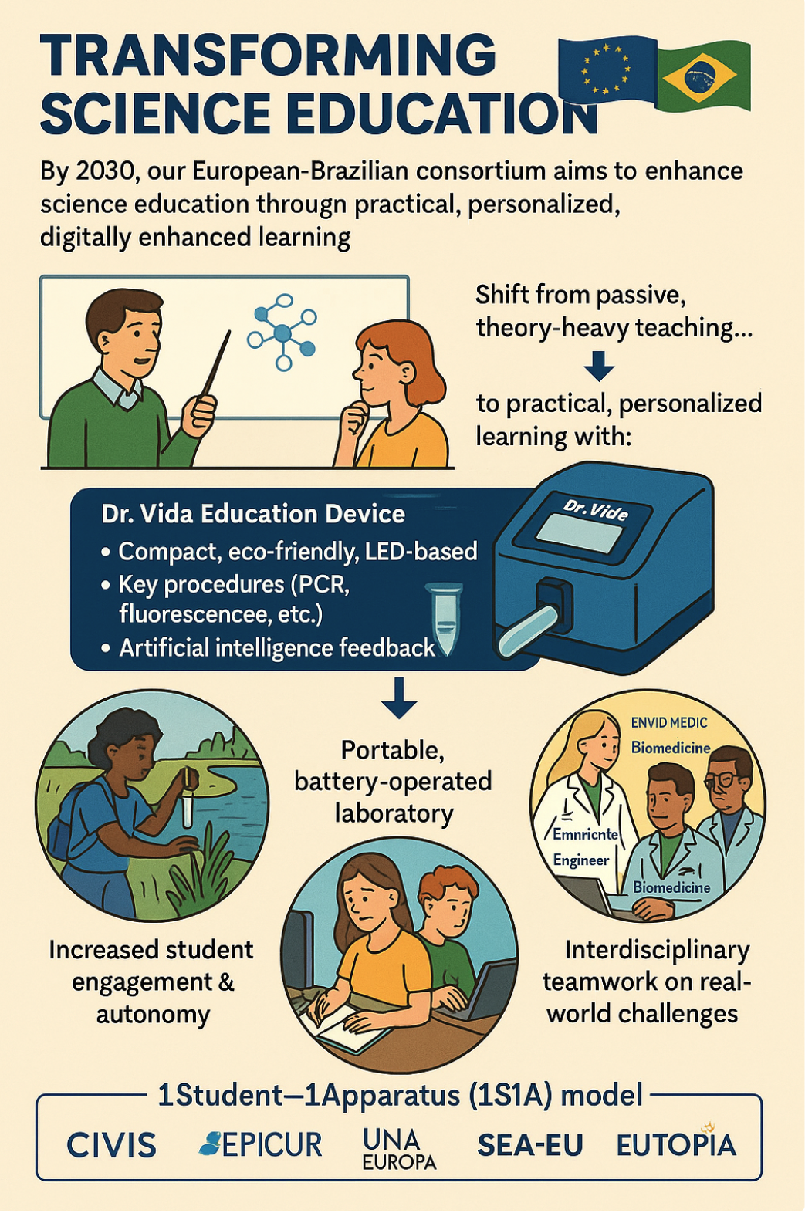

**Table A: Description of Alliance of Alliances + Brazilian Universities.**

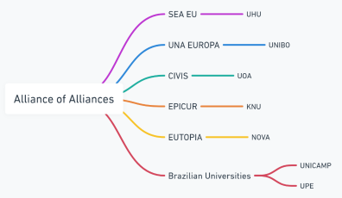

| [**EUTOPIA: NOVA**](https://www.unl.pt/eutopia/) and University of Warwick (UK), Vrije Universiteit Brussel (Belgium), CY Cergy Paris Université (France), University of Gothenburg (Sweden), Pompeu Fabra University (Spain), Technische Universität Dresden (Germany), Ca’ Foscari University of Venice (Italy), Babeș-Bolyai University (Romania), and University of Ljubljana (Slovenia). [**EPICUR: KNU**](https://epicur.edu.eu/?utm_source=chatgpt.com) and University of Strasbourg (France, coordinator), Adam Mickiewicz University in Poznań (Poland), Albert-Ludwigs-Universität Freiburg (Germany), Aristotle University of Thessaloniki (Greece), University of Amsterdam (Netherlands), Karlsruher Institut für Technologie (Germany), University of Natural Resources and Life Sciences in Vienna (Austria), University of Haute-Alsace (France), and University of Southern Denmark (Denmark). [**CIVIS: UOA**](https://civis.eu/), alongside Université libre de Bruxelles (Belgium), Universidad Autónoma de Madrid (Spain), Aix-Marseille Université (France), Sapienza Università di Roma (Italy), Eberhard Karls Universität Tübingen (Germany), University of Glasgow (UK), University of Bucharest (Romania), and Stockholm University (Sweden). CIVIS also includes associated partner institutions such as the University of Lausanne (Switzerland), Université Hassan II de Casablanca (Morocco), University of the Witwatersrand (South Africa), and University of Chile (Chile). [**UNA Europa: UNIBO**](https://site.unibo.it/una-europa/en)and Freie Universität Berlin (Germany), KU Leuven (Belgium), Université Paris 1 Panthéon-Sorbonne (France), University of Edinburgh (UK), Jagiellonian University in Kraków (Poland), Universidad Complutense de Madrid (Spain), University of Leiden (Holland), University College Dublin (Ireland), and the University of Zurich (Switzerland) as an associate partner. [**SEA-EU: UHU**](https://sea-eu.org/) and University of Cádiz (Spain, coordinator), University of Western Brittany (France), University of Gdańsk (Poland), University of Kiel (Germany), University of Split (Croatia), University of Malta (Malta), University of Algarve (Portugal), University of Naples Parthenope (Italy), and Nord University (Norway). Brazilian Universities: **UPE&UNICAMP** and (from Brazil). University of São Paulo, Federal University of Rio de Janeiro – UFRJ, Federal University of Minas Gerais – UFMG, São Paulo State University – UNESP, Federal University of Rio Grande do Sul – UFRGs, Federal University of Santa Catarina – UFSC, Federal University of Paraná – UFPR, University of Brasília – UnB. |
| --- |

**Policy Alignment:** European & Brazilian Priorities: The project is fully aligned with the EIT HEI Initiative and several key policy frameworks in Europe and Brazil, addressing innovation, inclusion, and sustainability in higher education as follows: [**(i) European Green Deal:**](https://commission.europa.eu/strategy-and-policy/priorities-2019-2024/european-green-deal_en)Dr. Vida follows the analytical minimalism concept, minimizing environmental footprint while ensuring accurate scientific outcomes. This aligns with [Brazil’s Rede UniSustentável](https://redeunisustentavel.com.br/), the GreenMetric ranking, and Green Campus initiatives promoting sustainable operations in universities. [**(ii) EU Digital Education Action Plan (2021–2027):**](https://education.ec.europa.eu/focus-topics/digital-education/plan) Through AI and bioinformatics, Dr. Vida supports personalized and data-driven learning. This mirrors Brazil’s innovation in hybrid education led by [UNIVESP](https://univesp.br/) and the [Federal Institute of Ceará (IFCE)](https://ifce.edu.br/), which integrate sustainability and entrepreneurship in their digital learning ecosystems. **(ii)** [**European Skills Agenda:**](https://employment-social-affairs.ec.europa.eu/policies-and-activities/skills-and-qualifications/european-skills-agenda_en) The project contributes to upskilling and reskilling efforts in digital and scientific domains, particularly in data literacy, laboratory autonomy, and problem-solving. **(iii)** [**EU Recommendation on Key Competences for Lifelong Learning:**](https://education.ec.europa.eu/focus-topics/improving-quality/key-competences) Dr. Vida enhances competences in digital literacy, science and technology, and entrepreneurship. This vision is echoed by Brazil’s [Porto Digital](https://www.portodigital.pt/), a thriving innovation hub that connects academia, startups, and public institutions to build capacity for digital transformation. **Impact and Reach (Table B):** By 2030, the project aims to implement Dr. Vida in at least 49 Europeans´ HEIs, 14 global HEIs, including 10 universities in Brazil. Through innovation boot camps, international workshops, staff exchanges, and conference participation, the project will ensure the dissemination and long-term sustainability of its results via one start-up. These actions will be further reinforced by the NOVA-FCT-Bioscope network, which already organizes 13 international scientific conferences every two years (www.bioscopegroup.org/conferences), offering an ideal platform for showcasing outcomes, recruiting collaborators, and engaging external stakeholders. In summary, this initiative harnesses the collective intelligence, mobility infrastructure, and digital integration capacity of the “Alliance of Alliances” to revolutionize science education and foster lasting EU–Brazil cooperation in education, research, and innovation.

**Communities (KICs)**:

**EIT Health**: By integrating bioinformatics tools and supporting epidemiological studies, the device contributes to advancements in medical education and research, addressing critical global health challenges.

**EIT Climate-KIC**: The device’s eco-friendly design and applications in sustainability (e.g., water contamination monitoring) align with goals to tackle climate change through innovation.

**Table B. SMART-A2 Project's IVAP: Phases, Actions | Objectives, and respective SMART characteristics.**

| **Phase** | **Action | Objective** | **S**pecific | **M**easurable | **A**chievable | **R**elevant | **T**ime bound |
| --- | --- | --- | --- | --- | --- | --- |
| **Phase 1**  **(2026-2030)**  **Foundation and Pilot Implementation** | **1**  Develop and Integrate the Device into Beneficiaries´ Curricula | Pilot program with beneficiaries | At least 40 teachers and 1500 students involved in first phase | Experts Consortium | Practical science education | Full Integration by the end of 2027 |
| **2**  Build an Innovation Network within European Alliances **SMART-A2** | Building **SMARTUP** a Startup on Education | Education program extended at least to 53 HEIs | Utilize UNL-BIOSCOPE Conferences & expertise to promote/Training | Collaboration between HEIs Alliances | **SMARTUP** Fully operational by the end of Phase 1 |
| **Phase 2**  **(2027-2030)**  **Expansion and Impact Enhancement** | **3**  Scale Adoption Across European Alliances and Brazil | Expand the program to 20 HEIs across America/Asia | At least 200 teachers and staff and 10000 students | Utilizes HEIs Alliances infrastructure | Promotes Europe-wide educational and research sharing and transformation | Complete scaling by the end of 2029 |
| **4**  Foster sharing HEIs Skills | Boot Camps for learning | Promotes the hands on training of 240 teachers and Staff | KIC partners for mentoring and funding | Aligns with enhancing employability | Boot camps operational by last semester 2027 |
| **Phase 3**  **(2026-2030).**  **Institutionalization and Global Outreach** | **5**  Institutionalize the Program | Institutionalize the Program | Integrate the device into the core curricula of at least 53 HEIs in Europe/America/Asia | Insert into degree accreditation standards | Long-term systemic change in education | Institutionalization completed by the end of 2029 |
| **6**  Strengthen Global Partnerships | Program globalization | Collaborations with at least 14 universities out of Europe | Europe’s leadership in educational innovation | Expands Europe’s impact on global education | Partnerships working by the end of 2027 |

**1.2. Coordination and/or support measures and methodology** #@CON-MET-CM@# #@COM-PLE-CP@#

[e.g. 6 pages]

**1.2.1 Overall methodology and concepts**

*Describe the overall methodology, including the concepts, models and assumptions that underpin your work. Explain how this will enable you to deliver your project’s objectives. Refer to any challenges you may have identified in the chosen methodology and how you intend to overcome them.*

*If you plan to use, develop and/or deploy artificial intelligence (AI) based systems and/or techniques you must demonstrate their technical robustness. AI-based systems or techniques should be, or be developed to become:*

*• technically robust, accurate and reproducible, and able to deal with and inform about possible failures, inaccuracies and errors, proportionate to the assessed risk they pose*

*• socially robust, in that they duly consider the context and environment in which they operate*

*• reliable and function as intended, minimizing unintentional and unexpected harm, preventing unacceptable harm and safeguarding the physical and mental integrity of humans*

*• able to provide a suitable explanation of their decision-making processes, whenever they can have a significant impact on people’s lives.*

Need to include a paragraph about this: *If you plan to use, develop and/or deploy artificial intelligence (AI) based systems and/or techniques you must demonstrate their technical robustness. AI-based systems or techniques should be, or be developed to become:*

*• technically robust, accurate and reproducible, and able to deal with and inform about possible failures, inaccuracies and errors, proportionate to the assessed risk they pose*

*• socially robust, in that they duly consider the context and environment in which they operate*

*• reliable and function as intended, minimizing unintentional and unexpected harm, preventing unacceptable harm and safeguarding the physical and mental integrity of humans*

*• able to provide a suitable explanation of their decision-making processes, whenever they can have a significant impact on people’s lives.*

Science education programs in Europe and Brazil are often criticized for being overly theoretical, limiting students’ preparedness for real-world [applications](https://www.iop.org/sites/default/files/2019-09/practical-work-in-science.pdf?utm_source=). Many institutions prioritize traditional, knowledge-heavy teaching over practical, hands-on learning, constrained by limited resources, large class sizes, and regulatory frameworks such as [REACH](https://eur-lex.europa.eu/legal-content/en/ALL/?uri=CELEX%3A32006R1907&utm_source). Northern European countries like Finland and Sweden have successfully integrated experiential learning, achieving a better balance between theory and practice. In contrast, institutions in Southern and Eastern Europe, as well as many in Brazil, face significant resource limitations, resulting in [curricula](https://publications.lib.chalmers.se/records/fulltext/203607/local_203607.pdf?utm_source=) that lack sufficient laboratorycomponents. In Brazil, São Paulo State dominates the R&D landscape, accounting for 46% of the national GERD and 66% of business R&D investment. However, a divide remains between research-intensive universities, which often emphasize theory, and teaching institutions, which may provide more practical training, albeit inconsistently. Reports such as the European Commission’s [Science Education for Responsible Citizenship](https://op.europa.eu/en/publication-detail/-/publication/a1d14fa0-8dbe-11e5-b8b7-01aa75ed71a1?utm_source=) (2015) and UNESCO’s *Global Education Monitoring* ([GEM](https://gem-report-2023.unesco.org/)) reports highlight the urgent need for inquiry-based and experiential learning to enhance scientific literacy. Despite the Bologna Process, implementation across Europe remains fragmented. National studies in countries like Germany and the UKconfirm that many science graduates feel underprepared for laboratory-based careers due to inadequate hands-on training during their studies. While virtual labs and interdisciplinary fields like bioinformatics offer alternative training platforms, they cannot fully replace real laboratory experience. Addressing these challenges requires curriculum reform that promotes a true balance between theory and practice, supported by modernized laboratories, [smaller](https://www.hks.harvard.edu/sites/default/files/Academic%20Dean%27s%20Office/Guide%20to%20Small-Group%20Learning.pdf) lab groups (ideally one student per group), and comprehensive faculty training. **To bridge these gaps, science education must align with** [**EU**](https://europass.europa.eu/en/europass-digital-tools/european-qualifications-framework?utm_source=) **and** [**UNESCO**](https://uis.unesco.org/en/topic/international-standard-classification-education-isced?utm_source=) **educational frameworks, enhance the use of technology, and foster institutional partnerships through the exchange of teaching, technical, and administrative staff. Systemic reforms are essential to ensure graduates are equipped with the practical skills required for today’s scientific workforce.** In addressing these challenges, our team has developed a prototype of an **affordable yet powerful small device referred as** [**Dr. Vida Education**](https://smartupdreducation.wixsite.com/welcome)**,** which offers a transformative solution. This device integrates UV and visible LEDs for excitation and supports measurements of both fluorescence and phosphorescence. In addition, Dr. Vida presents the functionality of a compact **PCR system**, and applications in **analytical, bioanalytical, and clinical biochemistry**. Additionally, its adaptability and transportability make it suitable for **environmental studies** (e.g., pollutant monitoring) and **clinical medicine research** (e.g., point-of-care diagnostics), and also for bioinformatics and for electrical engineering applications. Such a tool directly addresses gaps in hands-on scientific training by providing teachers and students with access to cutting-edge technologies at a fraction of traditional costs, one unit less than 1000 euros. Its compact design ensures that even resource-constrained institutions can offer robust experimental opportunities, which is remarkable for developing countries and remote areas. **What is more important, for the first time a one-student-one-apparatus concept can be achieved, allowing personalized learning and teacher-student interaction through experimental classes in the theoretical classroom.** The device supports environmental studies by monitoring pollutants like heavy metals and organic contaminants in water, soil, and air, enabling real-time environmental monitoring for conservation and compliance. In clinical fields, its compact PCR functionality facilitates on-site diagnostics for diseases, while fluorescence-based diagnostics aid biomarker detection and therapeutic decisions. Industrial applications include quality control in pharmaceuticals, food, and cosmetics, as well as process optimization. Dr. Vida Education also advances public health education by enabling disease surveillance and pathogen tracking in remote areas. **Its affordability and portability democratize access to quality science education, particularly in under-resourced regions, promoting STEM careers and equitable access to advanced tools.**

The **Innovation Vision Action Plan (IVAP)**  ensures that strategic actions address critical challenges in European and Brazilian science education. The self-assessment highlighted the need for stronger leadership to champion experiential learning and curricular innovation.

The findings of the HEInnovate self-assessment directly inform the selection of actions within the IVAP.Curriculum design focuses on embedding Dr. Vida Education into multidisciplinary courses to bridge theoretical and practical learning. Faculty development workshops make educators and academic staff to interchangue educational skills, ensuring effective integration of the device. A phased rollout plan enables the scaling of the device’s adoption across **all members of the Alliance of Alliances, summing a total of 49 European HEIs, plus 10 HEIS from Brazil plus 4 associated universities.** Collaboration hubs facilitate knowledge sharing and technical support, and **international** partnerships are fostered to promote global collaboration.

In conclusion, the **HEInnovate self-assessment** has been instrumental in identifying institutional needs and opportunities, shaping the IVAP to deliver targeted and impactful actions.

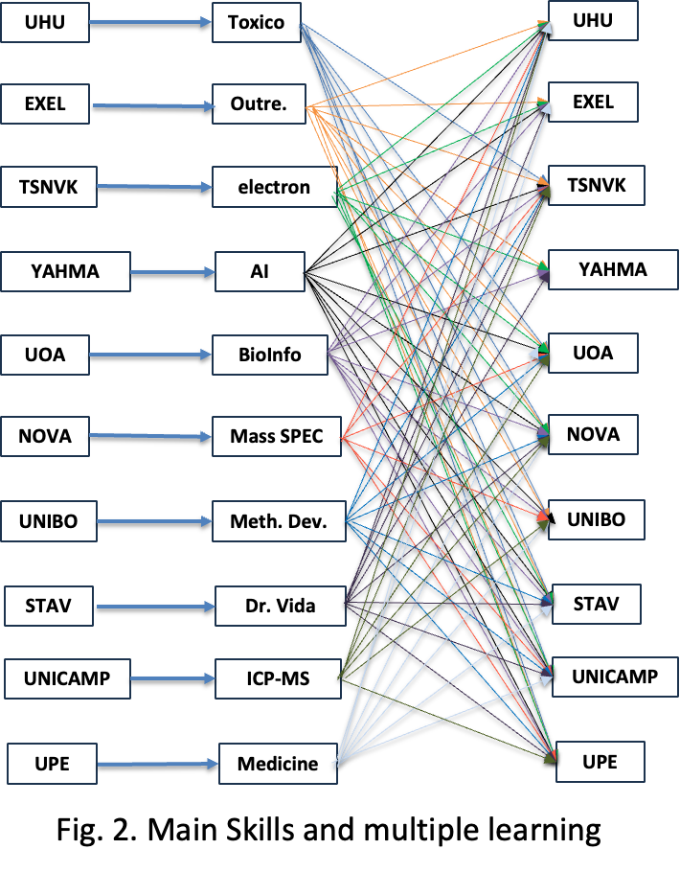

The integration of expertise and methods from different disciplines is central to achieving the objectives outlined in this project. This is reflected in Fig. 2 and Table C. Each type of teacher, technician and student attending any of these degrees: (Bio)informatics, Chemistry or Biochemistry, Environment, Pharmacy, Physics, electrical engineering and Medicine and Biomedicine will bring unique skills and perspectives that will be harmonized to foster interdisciplinary collaboration and innovation. As depicted in Table D. In this project, teachers, technicians and students will apply their unique expertise via **Dr. Vida Education** and actively teach and learn from one another, fostering a collaborative and interdisciplinary approach. This knowledge exchange ensures a deeper understanding of complex challenges and promotes holistic problem-solving while promoting the integration of the **Alliance of Alliances.** All the Universities involved in this project have chosen degrees to implement the concept of Dr. Vida Education. The coordinators of the beneficiary institutions bring together a comprehensive and interdisciplinary skill set that spans all scientific and technological areas required for the project’s success. This well-distributed and thematically integrated expertise positions the consortium to address complex challenges at the interface of science, technology, education, and societal needs, while fostering impactful and sustainable innovation. During this project teachers, technicians and students will be distributed into multidisciplinary teams to conduct educational changes through the following laboratory works.

**1. Protein Analysis in Urine: Biochemistry teachers/students** prepare calibration curves to quantify urinary proteins; **medical teachers/students** discuss clinical implications for kidney disease, multiple myeloma, **bioinformatics teachers/students** automate data analysis using Python. Non-academic staff implement self-testing units to reduce bureaucracy. **2. Environmental Impact of Pharmaceuticals: Environmental teachers/students** detect pharmaceutical residues in water; **pharmacy teachers/students** assess chemical stability; **bioinformatics teachers/students** model pollutant dispersion using AI. Targets include **Hg**, **As**, and **bacterial contamination**.

**3. PCR Diagnostics for Public Health: Medical and Biomedical teachers/students** demonstrate PCR diagnostics; **biochemistry teachers/students** explain DNA amplification; **bioinformatics teachers/students** analyze epidemiological data. Case: **lactose intolerance screening, Salmonella and Legionella screening**

**4. LED-Based Instrumentation: Engineering and physics teachers/students** assemble and explain the Dr. Vida device; **science teachers/students** demonstrate its use in analytical labs, highlighting modularity and field applicability. In the first year, **eight experimental practices** will be conducted. **Urine** will serve as the primary sample, using **simulated urine** for clinical applications. For large-scale data interpretation, **public datasets** will be used to train students in cohort analysis. Furthermore, a dedicated research work package will **investigate the pedagogical impact** of using the **Dr. Vida device** for molecular biology education by conducting **controlled classroom trials, training workshops, and longitudinal studies**. These activities will examine how hands-on digital experimentation—such as **PCR-based simulations**—enhances **conceptual understanding, scientific reasoning, and engagement** across different educational levels. This approach bridges disciplines, fostering collaboration and practical skill development. AI robustness and Trustworthiness of AI: As part of Task 2.2, all AI-enabled features in the **SMART-A2** Dr. Vida Education platform—including automated feedback, basic pattern recognition in student results, and quality checks that support teachers—will be developed following a clear, risk-proportionate robustness framework. Because these tools operate in a low-risk educational environment, we focus on reliability, transparency and controlled behaviour rather than complex autonomy. Each AI module will be validated with pilot data from several universities to ensure accuracy and reproducibility, and the system will flag uncertainty or potential errors so teachers and students understand when results should be interpreted with caution. The tools will remain socially robust by being shaped around the real teaching contexts encountered during the co-design sessions in the first months, ensuring they support—not replace—educator judgement. All processing will follow GDPR obligations, with strict minimisation of personal data and a data-protection impact assessment conducted from the start. Whenever the AI influences feedback or progression insights, the system will provide simple, accessible explanations so that users can understand why a suggestion or prompt was generated. This approach guarantees that the AI operates safely, avoids unintended harm, safeguards the well-being of students, and remains fully aligned with the project’s educational mission and institutional requirements.

**Table C. Doctor VIDA Education, type of teacher/technician/student and learning outcome (LerO) and skills (Sk)**

| **Teacher, technician and student** | **Learning Outcomes (LerO) and Skills (Sk)** |
| --- | --- |
| **(Bio) Informatics** | **LerO:** Deep Programming: (LabVIEW, MATLAB, Python), Signal Processing Software (MATLAB, Python, Octave), and Data Visualization Tools (Python, MATLAB, Tableau, and Excel). **Sk**: How to Interface Electronic Devices with Computers, Printers, and Mobile Devices. Hands-On Laboratory Work. |
| **(Bio) Chemistry** | **LerO:** Spectrophotometry, Fluorescence, Quality Control, Preconcentration, Analytical Separations, Experimental Error, Statistics, AI, Python, Chemical Measurements, and Kinetics. **Sk**: Deep Concepts of Analytical and Bioanalytical Chemistry. Hands-On Laboratory Work. |
| **Environment** | **LerO:** Water and Wastewater Management. Analysis of Pollutants (Metals and Organics), AI, Python, and Chemical Measurements. **Sk**: Management of water and wastewater. Hands-On Laboratory Work. |
| **Pharmacy** | **LerO:** Spectrophotometry, Fluorescence, Quality Control, Preconcentration, Analytical Separations, Experimental Error, Statistics, AI, Python, Chemical Measurements, Pharmacokinetics, Drug Analysis, and PCR. **Sk**: Analysis of Drugs and Metabolites, Hands-On Laboratory Work. |
| **Medicine** | **LerO:** Epidemiology, PCR Applications, Case Studies, Statistics, AI, Python, and Chemical Measurements. **Sk**: PCR Analysis, DNA and Medicine, Statistics for Epidemiology. Hands-On Laboratory Work. |
| **Physics and Electrical Engineering** | **LerO:** Electronic Components and Assembly. Epidemiology, PCR Applications, Case Studies, Statistics, AI, Python, and Chemical Measurements. **Sk**: PCR Analysis, DNA and Medicine, Statistics for Epidemiology, Spectrophotometry, Fluorescence, Quality Control, Preconcentration. Hands-On Laboratory Work. |

**Table D. Integration of Expertise Through Staff Interchange and Peer Teaching. Some examples.**

| **(Bio)Inform** | **What They Can Teach**: Data acquisition, processing, and visualization techniques using tools such as Python, MATLAB, and Tableau. Advanced signal processing methods to refine and analyze experimental data generated in chemistry, pharmacy, or environmental studies. **What They Can Learn**: From **Biochemistry**: The importance of proper experimental setup, such as designing accurate calibration curves for spectrophotometric data. From **Medicine**: How processed data can be used to extract meaningful clinical insights, such as identifying patterns in epidemiological studies or biomarker analyses. |
| --- | --- |
| **(Bio)Chem** | **What They Can Teach**: How to create and validate calibration curves for quantifying analytes, such as total proteins in urine or pollutants in water. Experimental techniques for preconcentration, separations, and analytical error minimization, which can be applied in pharmacy, environmental studies, or medical diagnostics. **What They Can Learn**: From **Medicine**: The clinical significance of chemical measurements, such as the relevance of protein concentration in diagnosing kidney disease. From **Bioinformatics**: How to automate data processing and visualize complex datasets for more efficient analysis. |
| **Environment** | **What They Can Teach**: Methods for water and wastewater analysis, including pollutant quantification (e.g., metals and organics) and the use of AI for environmental monitoring. Insights into the ecological and health impacts of pollutants, offering context for pharmaceutical and medical applications. **What They Can Learn**: From **Pharmacy**: How to analyze the environmental persistence and degradation of pharmaceutical compounds. From **Biochemistry**: Techniques for detecting and quantifying pollutants using advanced analytical tools, such as fluorescence and spectrophotometry. |
| **Pharmacy** | **What They Can Teach**: Pharmacokinetics and drug metabolism, helping medical students and biochemists understand how drugs are absorbed, distributed, metabolised and excreted. Techniques for analyzing metabolites and validating the accuracy of drug testing protocols.  **What They Can Learn**: From **Medicine**: The clinical context of drug efficacy and safety, and how pharmacokinetic data informs treatment decisions. From **Environment**: The impact of pharmaceutical waste on ecosystems and how to develop environmentally friendly drugs. |
| **Medicine** | **What They Can Teach**: The clinical relevance of data, such as the medical significance of protein levels in urine or the implications of pollutant exposure on public health. How to link epidemiological data with chemical measurements to draw meaningful conclusions about population health. **What They Can Learn**: From **Bioinformatics**: Techniques to handle large datasets, such as epidemiological studies, and derive actionable insights through AI and statistical modeling. From **Biochemistry**: The chemical and bioanalytical foundations of diagnostic tools, such as PCR and fluorescence-based assays. |
| **Physics and Electrical Engineering** | **What They Can Teach**: Design and optimization of sensing technologies and instrumentation, covering signal processing, microfluidics, and embedded systems, for biomedical and environmental applications; development of hardware and electronic platforms for diagnostic devices such as biosensors and wearable monitors; and modeling and simulation of physical systems, energy transfer, and material interactions in analytical tools. **What They Can Learn**: From **Bioinformatics**: Techniques to handle large datasets, such as epidemiological studies, and derive actionable insights through AI and statistical modeling. From **Biochemistry**: The chemical and bioanalytical foundations of diagnostic tools, such as PCR and fluorescence-based assays. **From Medicine:** The clinical relevance of data, such as the medical significance of protein levels in urine or the implications of pollutant exposure on public health. How to link epidemiological data with chemical measurements to draw meaningful conclusions about population health. |
| **Non Academic Staff** | Through job shadowing, short-term training, technical visits, and workshops, non-academic staff will participate in **practical knowledge exchange**. Lab technicians ***train in equipment maintenance***(e.g., *Dr. Vida*), develop safety protocols, and support joint experiments. IT staff will focus on integrating digital platforms, managing experimental data, and implementing AI tools. **Administrative staff** will work on harmonising mobility processes, managing project finances, and tracking impact indicators. Educational support staff will create tutorials and assist teachers and students in using digital tools effectively. |

The project integrates the Knowledge Triangle—education, research, and business—by embedding the Dr. Vida Education device into higher education curricula to equip students with practical skills aligned with EU lifelong learning priorities. Collaborations among institutions such as UHU, NOVA, UOA, UNIBO UNICAMP, UPE, KNU and STABV ensure the device remains innovative and impactful across disciplines, while partnerships with industry, STABV and YAGHMA, facilitate market readiness, business model development, and commercialization. EXEL ensures dissemination and communication. KNU maintains technological updates of Dr. Vida education. The NOVA´s robust [Diversity and Inclusion Action Plan](https://www.unl.pt/en/noticias/nova/nova-university-lisbon-implements-gender-equality-plan/?utm_source=chatgpt.com) **prioritizes gender equality** and representation and will be implemented throughout the project. **UHU, UNIBO and UPE are led by females, NOVA is led by a non-binary person.** Outreach to underrepresented groups, including students from immigrant backgrounds and less-developed regions, will help ensure equitable access. Designing gender-sensitive tools, such as the "Dr. Vida Education" device, ensures inclusivity in **education** and healthcare applications.Monitoring gender balance throughout the project ensures accountability and continuous improvement. This approach aligns with [**UN SDG 5 (Gender Equality)**](https://sdgs.un.org/goals/goal5) andthe [**EUGender Equality Strategy 2020-2025**](https://ec.europa.eu/info/policies/justice-and-fundamental-rights/gender-equality/gender-equality-strategy_en), reinforcing the project's sustainability and impact. The affordability and portability of the device enable access in resource-limited contexts or remote regions, such as Brazil, Ukraine, Portugal and Greece, promoting equity in science education. The project’s IP strategy, guided by a Consortium Agreement, defines ownership and use while ensuring open access to research outputs. A GDPR-compliant Data Management Plan supports secure, transparent data handling, with protocols for collection, sharing, and storage. This comprehensive plan ensures long-term accessibility and reproducibility, reinforcing the project’s alignment with sustainability and innovation goals.

**1.2.2 Coordination and support measures**

*Describe and explain the coordination and/or support measures. Explain how this will enable you to deliver your project’s objectives.* 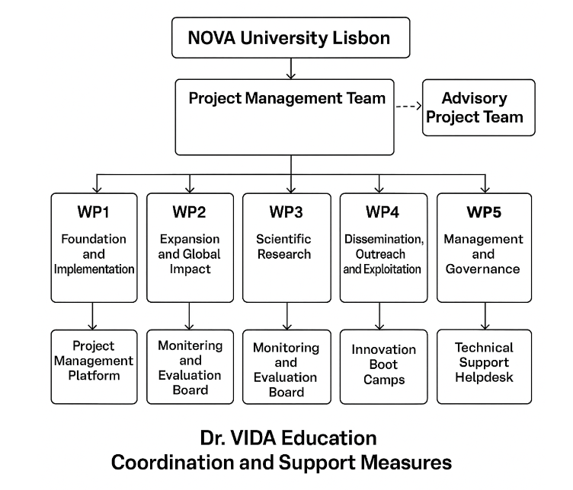

Several European-funded projects, such as [**OpenAIRE**](https://www.openaire.eu/)and [**Scientix**](https://www.scientix.eu/), serve as inspirations for this initiative. These projects promote open science, collaborative learning, and STEM education across Europe, aligning closely with the goals of the Dr. Vida Education project. Additionally, the [**Bologna Process**](https://education.ec.europa.eu/education-levels/higher-education/inclusive-and-connected-higher-education/bologna-process) provides a framework for harmonizing higher education across Europe, influencing the curriculum redesign strategies proposed in this project.The project employs a **matrix coordination structure** to ensure effective delivery of objectives, combining centralized management with distributed action-specific leadership.

The **Dr. VIDA Education** project is supported by a strong coordination and governance framework designed to ensure effective management, seamless collaboration among partners, and timely delivery of its ambitious objectives. The structure combines centralized coordination with decentralized implementation, allowing the multidisciplinary expertise and regional diversity of the consortium to achieve educational transformation, scientific advancement, and sustainable innovation.

The project is coordinated by **NOVA University Lisbon (Portugal)**, which leads both WP1 (Foundation and Implementation) and WP5 (Project Management). NOVA is responsible for ensuring strategic alignment, administrative efficiency, and scientific integrity across all work packages. A dedicated **Project Management Team (PMT)**—composed of **José Luís Capelo, Hugo Santos, Carlos Lodeiro**, and **Elisabete Oliveira (Portugal)**—oversees the day-to-day coordination, financial management, reporting, and communication between all partners, ensuring coherence and accountability. The PMT also manages the Consortium Agreement and Intellectual Property Rights (Task 5.3), guaranteeing transparent governance, compliance with EU standards, and secure data handling. An **Advisory Project Management Team (Advisory PMT)**—including **Makis Zoidakis (Greece), Laura Mercolini (Italy),** and **Tereza Cartaxo (Brazil)**—supports the coordination activities with strategic, scientific, and pedagogical input. This advisory team ensures integration between educational and research components, provides risk mitigation advice, and supervises adherence to gender equality and open science principles. Decentralized leadership ensures that each Work Package (WP) benefits from expert oversight by the most qualified institution. **WP1** is led by NOVA (Portugal), **WP2 (Expansion and Global Impact)** by UPE (Brazil), **WP3 (Scientific Research)** by UNIBO (Italy) in collaboration with STABV (Portugal), **WP4 (Dissemination, Outreach and Exploitation)** by EXEL (Greece), and **WP5 (Management and Governance)** by NOVA (Portugal). The **Work Package Coordinators (WPCs)**—**José Luís Capelo (NOVA), Dimitris Raptis (Exel), Laura Mercolini (UNIBO),** and **Tereza Cartaxo (Brazil)**—guarantee coherent progress, regional coordination, and methodological consistency across all thematic areas. This distributed structure ensures ownership, responsiveness, and effective adaptation to local contexts. Efficient communication and coordination are supported by a comprehensive set of tools and procedures. A **Project Management Platform (PMP)** will serve as a central hub for documentation, budgeting, scheduling, and KPI tracking. Regular **quarterly WP meetings** and **annual General Assemblies** will review progress, address deviations, and update the implementation strategy. A **central digital archive** will store all official documents, meeting records, and deliverables (Task 5.2), ensuring full transparency and traceability. A **Technical Support Helpdesk** will be established to assist partner institutions with device deployment, calibration, and troubleshooting. Each higher education institution (HEI) will also implement its own **Innovation Vision Action Plan (IVAP)**, tailored to its academic structure and national context, to embed the “**1 Student – 1 Apparatus (1S1A)**” model and support institutional innovation. **Staff mobility and capacity building are at the core of the support framework.** The project will organize regular **faculty development workshops** to train educators in the pedagogical and technical use of the Dr. VIDA Education device and associated software. These sessions will promote digital pedagogy, interdisciplinary learning, and data-driven teaching methods. All training activities will be recorded and made available through the project’s web portal to ensure continuous access. Additionally, **Innovation Boot Camps** (Task 2.3) will train more than 240 educators in Europe, South America, Africa and Asia. **Monitoring and quality assurance** are ensured through a dedicated **Monitoring and Evaluation Board (MEB)** composed of WP leaders and Advisory PMT members. The MEB will supervise milestones (Table 3.1d), deliverables, and risk management (Table 3.1e). A **Gender and Inclusion Oversight Group**, coordinated by NOVA (Portugal), will ensure equitable participation and monitor diversity metrics throughout the project’s implementation. Risks related to technical performance, partner engagement, and regulatory compliance will be mitigated through redundancy in partner expertise, transparent communication, and GDPR-compliant data practices. **The digital infrastructure** of the project supports collaboration, open learning, and sustainability. The **SMART-A2 Dr. VIDA Education Web Portal** (Task 2.2) will centralize educational resources, experimental protocols, open-source analytical tools, and AI-assisted guidance systems for students and teachers. Artificial intelligence modules will provide adaptive learning support, automated feedback, and real-time data visualization, enhancing personalized education and fostering innovation in STEM learning. **Institutionalization and sustainability** beyond the project’s duration are key priorities. The creation of the **SMARTUP startup** (Task 1.3), coordinated by NOVA (Portugal), will ensure the continuity of the Dr. VIDA Education device’s technological development, market deployment, and pedagogical adaptation. The **curriculum integration frameworks** developed in WP2.4 will align the device and learning modules with HEI accreditation requirements, ensuring long-term adoption. A comprehensive **Exploitation Strategy** (Task 4.3) will support the identification of new funding opportunities, intellectual property valorization, and the expansion of Dr. VIDA Education across global academic networks. **Project governance** is further reinforced through a **Project Steering Committee (PSC)** composed of representatives from all partner institutions, meeting quarterly to review progress and strategic alignment. The PSC includes **José Luís Capelo (NOVA), Tereza Cartaxo (UPE), Marco Aurélio Zezzi Arruda (UNICAMP), Michalis Zoidakis (UOA), Tamara Garcia-Barrera (UHU), Laura Mercolini (UNIBO), Oleg Olikh (TSNUK), Octavio Flores (STABV), Yagma (YAGMA)**, and **Dimitrios Raptis (EXELL)**. **External guidance and quality assurance** are provided by an independent **Scientific and Educational Advisory Board (SEAB)** comprising leading international experts: **Magdalena Biesaga (Poland), Manuel Miró (Spain), Jacek Wisniewski (Germany), Pierre-Olivier Schmit (Germany)**, and **Masaru Miyagi (USA)**. The SEAB will meet annually to evaluate project performance, provide strategic recommendations, and ensure excellence across scientific, pedagogical, and technological dimensions. Through this coordinated and multi-level structure—combining centralized management, distributed leadership, continuous training, digital integration, and independent evaluation—the Dr. VIDA Education project will ensure efficient implementation, accountability, and lasting impact within the European and global higher education landscape. The coordination framework directly supports (see table B) **Objective 1** (*Develop and Integrate the Device into Beneficiaries´ Curricula*) by embedding Dr. VIDA Education into STEM programs and promoting hands-on learning. Strong governance structures also advance **Objective 2** (*Build an Innovation Network within European Alliances*), fostering collaboration across universities, research institutes, and industry. Ensuring equitable access supports **Objective 3** (Scale Adoption Across European Alliances and Brazil), enabling resource-constrained HEIs to benefit from this digital transformation, consistent with the [**European Skills Agenda**.](https://employment-social-affairs.ec.europa.eu/policies-and-activities/skills-and-qualifications/european-skills-agenda_en) Innovation boot camps and hands-on problem-solving activities advance **Objective 4** (*Foster sharing HEIs Skills*), providing researchers and students with real-world challenges and new technical competencies. Key barriers—such as limited lab infrastructure, faculty expertise, and funding—are addressed through **Objective 5** (*Institutionalize the Program*), which prioritizes faculty training and investment in experimental learning environments.The coordination design ensures teachers and students engage with cutting-edge tools for data collection, analysis, and visualization—contributing to **Objective 6** (*Strengthen Global Partnerships*) and aligning with the **EU** [**Digital Education Action Plan (2021–2027)**](https://education.ec.europa.eu/focus-topics/digital-education/plan) and the [**EIT Knowledge Triangle**,](https://www.eitmanufacturing.eu/what-we-do/the-eit-knowledge-triangle/) which links education, research, and innovation. Finally, these actions support adoption metrics under **Objective 3** and reflect the values of the [**European Commission’s Science Education for Responsible Citizenship**](https://op.europa.eu/en/publication-detail/-/publication/a1d14fa0-8dbe-11e5-b8b7-01aa75ed71a1/language-en) framework.

**1.2.3 Open Science Practices**

*Describe how appropriate open science practices are implemented as an integral part of the proposed methodology. Show how the choice of practices and their implementation are adapted to the nature of your work, in a way that will increase the chances of the project delivering on its objectives [e.g. 1 page, including research data management]. If you believe that none of these practices are appropriate for your project, please provide a justification here.*

*Open science is an approach based on open cooperative work and systematic sharing of knowledge and tools as early and widely as possible in the process. Open science practices include early and open sharing of research (for example through preregistration, registered reports, pre-prints, or crowd-sourcing); research output management; measures to ensure reproducibility of research outputs; providing open access to research outputs (such as publications, data, software, models, algorithms, and workflows); participation in open peer-review; and involving all relevant knowledge actors including citizens, civil society and end users in the co-creation of R&I agendas and contents (such as citizen science).*

*Please note that this question does not refer to outreach actions that may be planned as part of communication, dissemination and exploitation activities. These aspects should instead be described below under ‘Impact*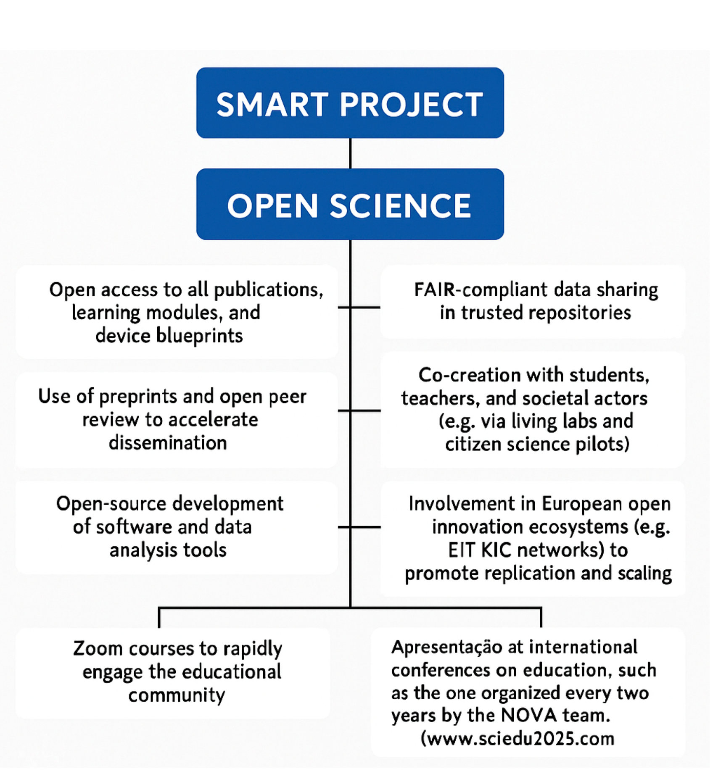

The **SMART-A2** project embraces Open Science as a central tenet, ensuring that research outputs and learning resources are freely available and co-created with end users. Key practices include (i) open access to all publications, learning modules, and device blueprints; (ii) use of preprints and open peer review to accelerate dissemination; (iii) open-source development of software and data analysis tools; (iv) FAIR-compliant data sharing in trusted repositories; (v) co-creation with students, teachers, and societal actors (e.g., through living labs and citizen science pilots); (vi) involvement in European open-innovation ecosystems (e.g., EIT KIC networks) to promote replication and scaling; (vii) Zoom-based courses to rapidly engage the educational community; and presentations at international education conferences, including the biennial event organized by the NOVA team ([www.sciedu2025.com](http://www.sciedu2025.com)). This strong commitment to openness will ensure broad uptake and long-term sustainability of the project results. **A dedicated webpage already exists for Dr. Vida Education**, serving as the seed of the future open portal for disseminating all information and materials created through this project, including a short explicative video of the project (<https://smartupdreducation.wixsite.com/welcome>, password: SMART).

**1.2.4 Research data management and management of other research outputs**

*Research data management and management of other research outputs: Applicants generating/collecting data and/or other research outputs (except for publications) during the project must provide maximum 1/2 page on how the data/research outputs will be managed in line with the FAIR principles (Findable, Accessible, Interoperable, Reusable.*

All research data and educational outputs generated by the project will be managed in accordance with the FAIR principles—Findable, Accessible, Interoperable, and Reusable. Metadata will be structured using standard ontologies and deposited in public registries; data will be stored in institutional or EU repositories (e.g., Zenodo, OpenAIRE) with open access under CC BY or equivalent licenses; file formats will comply with community standards (e.g., CSV, JSON, XML) and will be fully documented to ensure reproducibility; and comprehensive documentation, version control, and licensing information will be provided to facilitate reuse by the community. **A Data Management Plan (DMP) will be submitted within the first three months** of the project and updated annually. NOVA will lead the DMP development, while the Project Steering Committee (PSC) will oversee its preparation and submission for approval to the Scientific and Ethical Advisory Board (SEAB), in coordination with all data-generating partners. Research outputs beyond data—including software, device protocols, and training materials—will be made openly available through the project’s dedicated web page

**2. Impact** #@IMP-ACT-IA@#

**2.1. Project’s pathways towards impact**

[e.g. 4 pages]

*Provide a narrative explaining how the project’s results are expected to make a difference in terms of impact, beyond the immediate scope and duration of the project. The narrative should include the components below, tailored to your project.*

1. *Describe the unique contribution your project results would make towards (1) the outcomes specified in this topic, and (2) the wider impacts, in the longer term, specified in the respective destinations in the work programme.*

* *Be specific, referring to the effects of your project, and not R&I in general in this field.*
* *State the target groups that would benefit. Even if target groups are mentioned in general terms in the work programme, you should be specific here, breaking target groups into particular interest groups or segments of society relevant to this project.*

The **SMART-A2 project** revolutionizes science education by realizing the *one-student–one-apparatus* vision through the seamless integration of the **Dr. Vida Education device** into higher education curricula. Beyond transforming student learning, the project strengthens the **Alliance of Alliances** network by fostering meaningful collaboration among all participating universities — including the **Brazilian institutions** — within a coordinated framework of teaching and learning. This structure enhances the **mobility and compatibility of Erasmus exchanges**, benefiting not only students but also **academic, non-academic, and technical staff**. By promoting shared pedagogical standards, joint training initiatives, and transdisciplinary interaction across **49+4+10 HEIs**, **SMART-A2** deepens institutional cooperation and creates a cohesive, dynamic community of practice. Its unique contribution lies in embedding **hands-on, technology-enhanced learning** into theoretical education while building lasting networks that extend well beyond the project’s lifespan.

Unique Contribution to Expected Outcomes and Wider Impacts

**(i) Contribution to Outcomes Specified in the Topic**

**(i.1) Practical Education Revolution**: The project establishes a "1-student-1-apparatus" model with Dr. Vida Education, allowing individualized, real-time experimental learning across disciplines like biochemistry, clinical diagnostics, environmental science, and bioinformatics. This directly contributes to Horizon Europe’s outcomes of fostering innovation capacity and improving science and technology education quality. **(i.2)** **Entrepreneurial and Digital Skills Training**: Through boot camps and curricula integration, students and educators gain hands-on skills in AI, data analysis, Python programming, and entrepreneurial problem-solving—advancing the EU’s Digital Education Action Plan and European Skills Agenda. **(i.3) Innovation Ecosystems**: The establishment of SMARTUP, a startup incubated within the project, exemplifies how academia-industry synergies can be fostered within HEIs. This supports the expected outcome of enabling HEIs to become central players in regional innovation ecosystems.

**(ii) Wider Long-Term Impacts**

**(ii.1) Institutional Change**: By institutionalizing the Dr. Vida Education and experiential learning practices across at least **49+4+10 HEIs** worldwide by 2030, thus contributing to structural reforms in education and accreditation standards, promoting a reliable use of the resources already working for the Alliance of Alliances. **(ii.2)** **Global Leadership and Knowledge Export**: Partnerships with **49+4+10 HEIs** ensure that Europe and Brazil not only co-leads in education innovation but also actively contributes to raising global standards in STEM education. **(ii.3) Sustainability and Social Equity**: The device's affordability promotes equitable access to quality education in resource-constrained regions, contributing to EU goals of inclusion (SDG 4, 5, and 10), while its minimal environmental footprint aligns with the Green Deal and sustainability targets.

Target Groups Benefiting from the Project. The following clearly defined interest groups will benefit directly: **Teaching Staff and graduate Students** in Biochemistry, Medicine, Environmental Sciences, Pharmacy, Informatics, Physics and Engineering—especially in underfunded institutions, **STEM Educators** who will be trained to implement experiential and interdisciplinary teaching models using Dr. Vida Education, **University Leadership and Curriculum Boards** that will adopt and accredit the integrated modules, Startups and SMEs in EdTech (e.g., STABV, YAGHMA), gaining access to innovative, market-ready educational products, **Policy Makers and Accreditation Agencies shaping national and EU-wide education standards**, **European Alliances of Universities by sharing educators and administrative staff**, and **Secondary Schools adapting practical learning to Dr. Vida education** are all direct beneficiaries of the project. **Scale and Significance of the Project’s Contribution**: (i) **By the end of 2027**: 1500 students and 40 educators trained in 8 HEIs. 8ii) **By the end of 2029**: 10,000 students and 200 educators trained in **49+4+10 HEIs** worldwide. (iii) **By 2035**: Project extended to teachers of medium schools. Expanded internationally via webpages and conferences to other alliances and Brazilian universities. This scale ensures Europe-wide uptake and international adoption, fostering systemic changes. The **significance** lies in enhancing employability, digital competencies, and scientific literacy while promoting educational equity and innovation. **Quantifiable Effects**: (i) +30% increase in student engagement, +40% improvement in practical learning outcomes, 1 new startup launched (SMARTUP), up to 500 educators trained in entrepreneurship and digital tools, and a transversal educational tool in all educational systems. Studies in STEM education demonstrate that hands-on learning and active experimentation can improve student engagement by 25–35% and practical skill acquisition by 30–50% (cf. Freeman et al., *PNAS*, 2014; Prince, *J. Eng. Educ.*, 2004). The individualized nature of the Dr. Vida Education device builds upon this foundation by ensuring full student access and autonomy, which is likely to amplify these documented benefits. The one-student-one-device approach eliminates common obstacles such as equipment sharing and passive observation, both of which have been identified in EU reports as detrimental to skill development ([EU Science Education Report,2023](https://education.ec.europa.eu/it/news/education-and-training-monitor-2023-encouraging-trends-but-challenges-remain?utm_source)). This model supports personalized and repeatable experimentation, fostering deeper conceptual retention and greater student confidence. Furthermore, the integration of artificial intelligence tools, real-time feedback mechanisms, and bioinformatics functionalities facilitates adaptive learning pathways. This aligns with findings from the OECD EdTech [Review](https://www.aitsl.edu.au/research/spotlights/evaluating-the-evidence-for-educational-technology-part-1-the-technologies?utm_source), which indicate that digital interactivity significantly enhances both engagement and performance in laboratory-based educational settings.

**2.1.1 Scientific Impact**

*e.g. contributing to specific scientific advances, across and within disciplines, creating new knowledge, reinforcing scientific equipment and instruments, computing systems (i.e. research infrastructures).*

The **SMART-A2** project is expected to generate substantial scientific impact by contributing to advances across and within multiple disciplines, particularly in the fields of analytical and bioanalytical chemistry, bioinformatics, molecular diagnostics, and science education. Through the development and deployment of the Dr. Vida Education device, the project will enable novel experimental methodologies that integrate fluorescence, UV-Vis, and PCR-based analysis **in a compact and affordable format.** These innovations will support new lines of inquiry in clinical diagnostics, environmental monitoring, and biochemical analysis. By embedding the device into practical teaching modules and interdisciplinary case studies (e.g., bioinformatics-driven pollutant modeling or epidemiological PCR diagnostics), the project fosters scientific literacy and cross-disciplinary research capabilities among students and educators. This aligns with broader EU goals to promote transdisciplinary research and bridge gaps between traditionally siloed fields such as medicine, data science, and environmental sciences.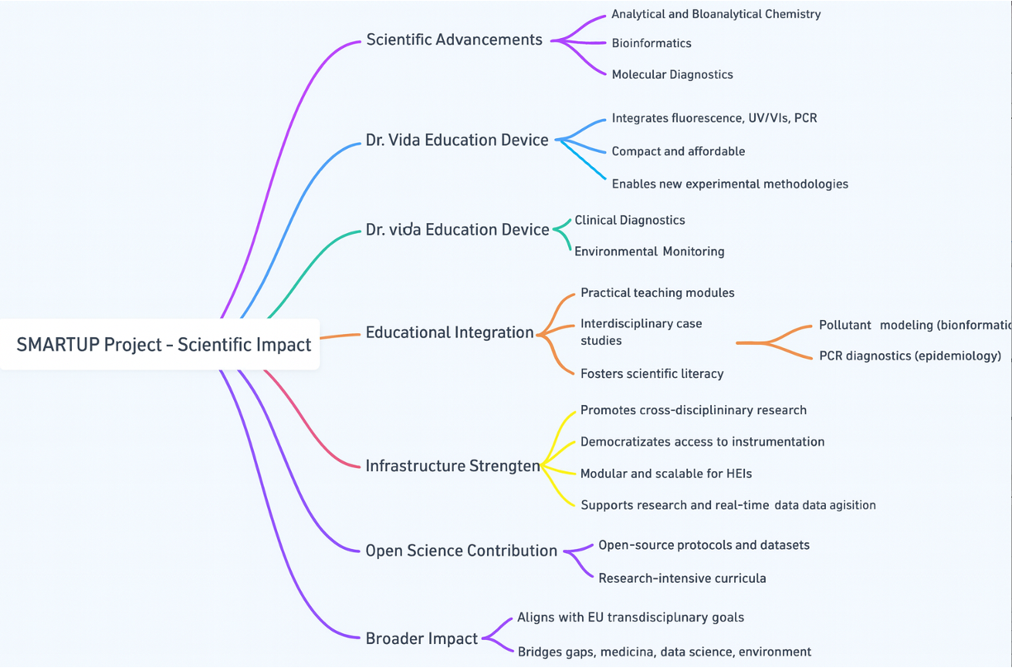

The device itself reinforces scientific infrastructure by democratizing access to advanced instrumentation. It provides HEIs—including those in resource-limited regions—with reliable, modular, and scalable equipment that can be used both in educational and research contexts. Its compatibility with AI-powered analytics and real-time data acquisition further supports the development of intelligent computing systems within research environments. Moreover, by generating open-source protocols and datasets, and by incorporating the device into research-intensive curricula, the project will contribute to the co-creation of new scientific knowledge. The Dr. Vida Education device will also enable scalable pilot studies and exploratory research in small labs or classrooms, thus functioning as a platform for methodological innovation and early-stage discovery science. Ultimately, Dr. Vida Education will reinforce Europe’s and Brazil’s scientific infrastructure by strengthening both human capital and experimental capabilities across a diverse range of institutions by the interchange of knowledge and expertise.

**2.1.2 Economic/technological impact**

*e.g. bringing new products, services, business processes to the market, increasing efficiency, decreasing costs, increasing profits, contributing to standards’ setting, etc.*

The **SMART-A2** project will generate significant economic and technological impact by introducing a new educational technology into the market as a scalable, multifunctional, and low-cost solution for hands-on scientific learning. This innovation brings together several capabilities (e.g., UV-Vis, fluorescence, PCR) in a single compact unit, dramatically reducing the need for multiple, expensive laboratory instruments in higher education and training environments. Economically, the project lowers the financial barriers associated with practical science education. Traditional laboratory setups often require investments exceeding €20,000 per lab unit; in contrast, the Dr. Vida Education device is designed to deliver equivalent core functionality at a fraction of the cost, around €1,000. This increases access for under-resourced institutions and enables broader adoption across regions, particularly in developing countries where budget constraints are a limiting factor.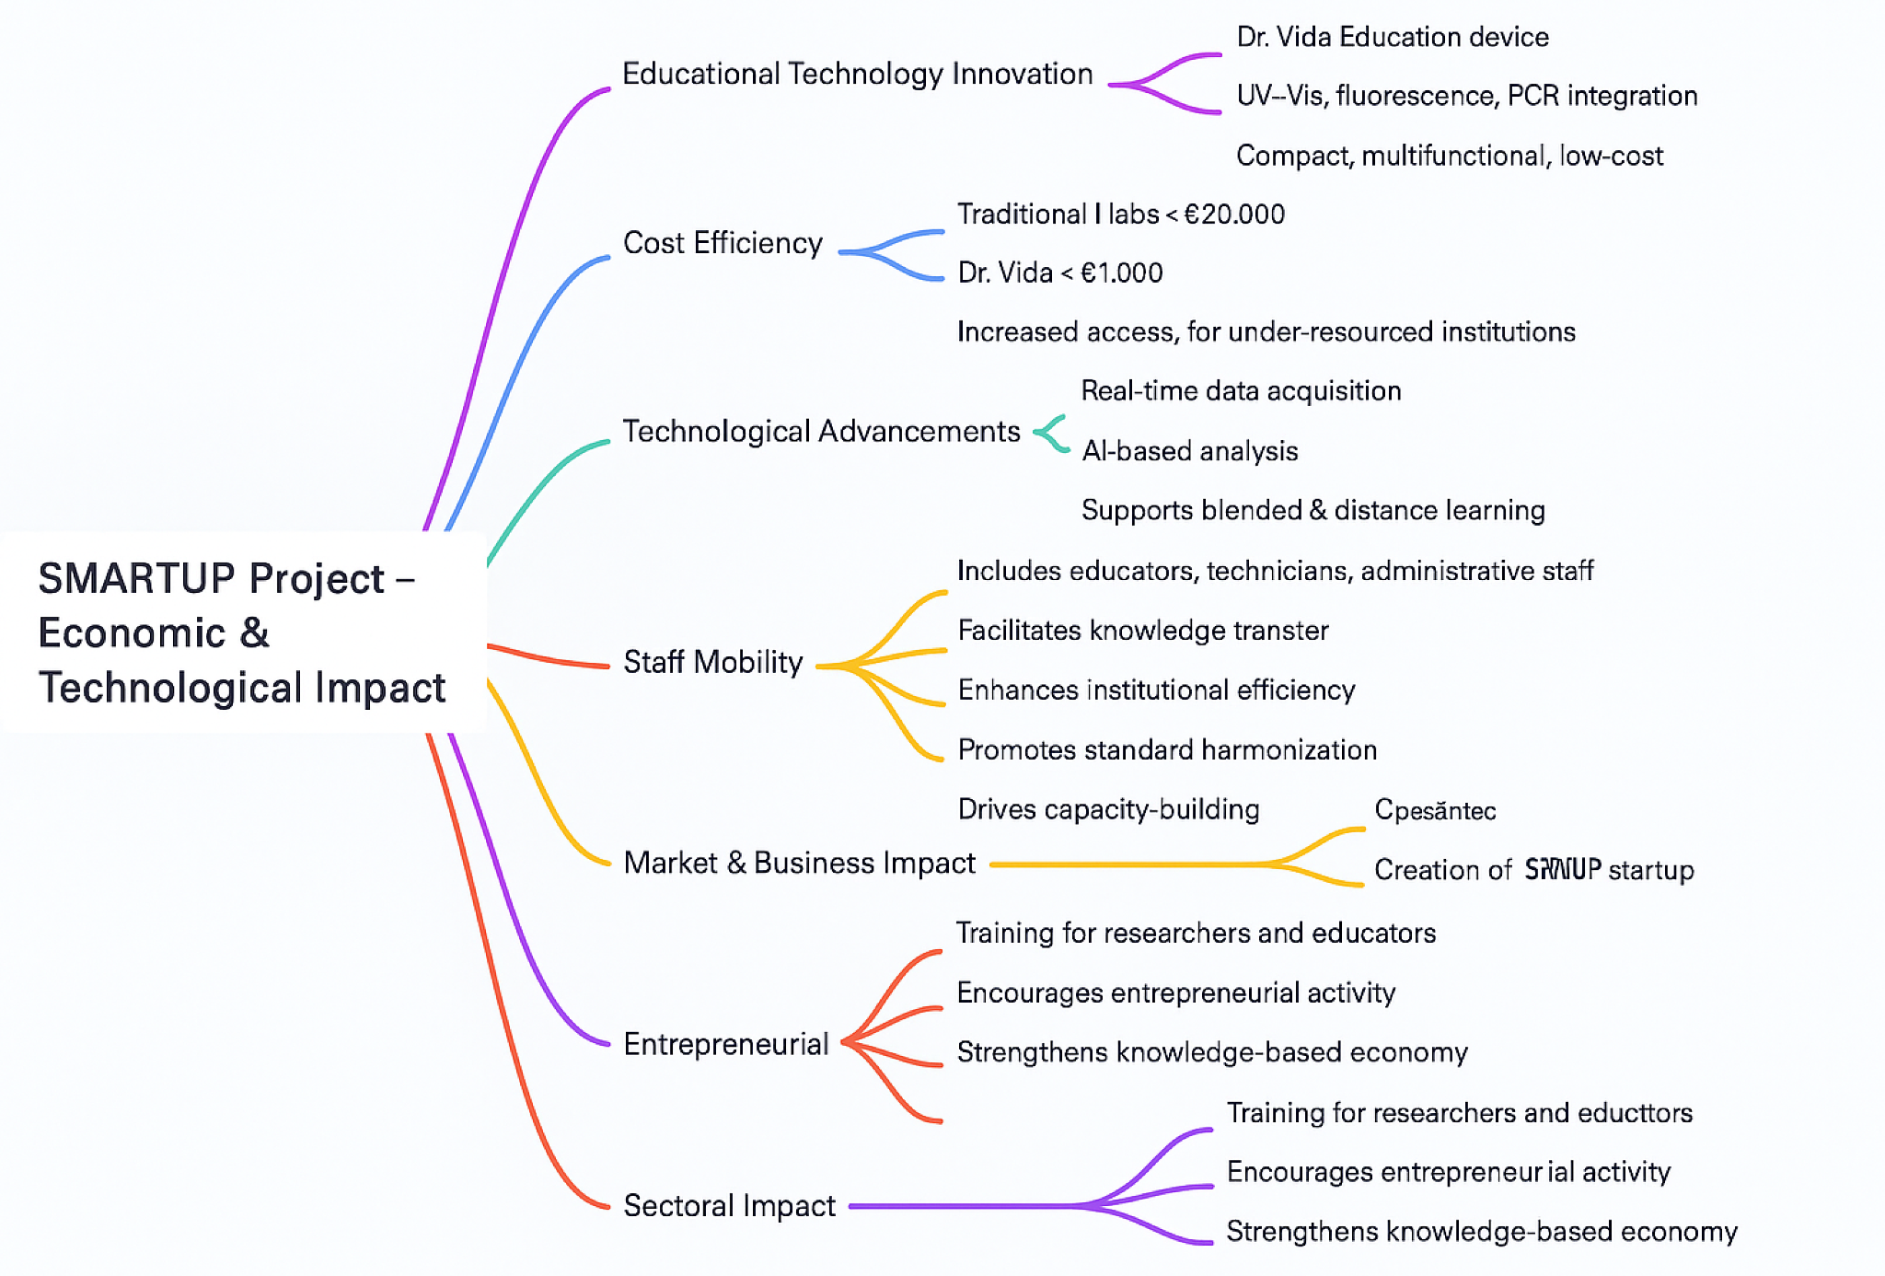

The project also promotes **staff mobility among the Alliance of Alliances**—including educators, technicians, and administrative personnel—**as a driver of institutional innovation.** By facilitating the exchange of personnel between partner institutions, the initiative accelerates the transfer of knowledge, best practices, and operational models. This not only improves institutional efficiency and reduces training costs but also helps harmonize technical standards and administrative procedures across borders. The movement of trained personnel fosters capacity-building and encourages the diffusion of technological and pedagogical innovations, generating spillover benefits in host and sending institutions alike. Technologically, the device integrates advanced features such as real-time data acquisition and AI-based analysis. These attributes not only support modern pedagogical models like blended and distance learning but also reflect industry-grade capabilities that prepare students for digitally enabled workplaces. In this way, the project accelerates the digital transformation of science education and strengthens the technological pipeline for sectors such as diagnostics, biotechnology, and environmental monitoring. The project also drives innovation in educational services and business models. Through the creation of the SMARTUP startup, the initiative will develop new distribution, support, and licensing mechanisms for the device, while also enabling future iterations and product extensions. Moreover, by training educators and researchers in how to apply and adapt the device—and mobilizing them across institutional and national contexts—the project contributes to a knowledge-based economy and supports entrepreneurial activity at the intersection of science, education, and technology.

**2.1.3 Societal Impact**

*e.g. decreasing CO2 emissions, decreasing avoidable mortality, improving policies and decision making, raising consumer awareness.*

The **SMART-A2** project will generate meaningful societal impact by promoting equitable access to quality science education, advancing public health awareness, and contributing to environmental sustainability. Through the deployment of the Dr. Vida Education device, students and educators will be empowered with tools to explore and address real-world societal challenges, including pollution, disease monitoring, and sustainable development. In terms of **environmental impact**, the device promotes the principle of analytical minimalism, enabling accurate scientific analysis using fewer reagents by requiring microquantities, less energy, and more compact, eco-friendly equipment. Its use in teaching environmental chemistry and pollutant detection—such as monitoring heavy metals in water—raises awareness among teachers, students and other non-academics staff as well as local communities about environmental health risks, thereby supporting broader goals of decreasing CO₂ emissions and toxic exposure through informed behavior and better practices. It can be deployed in the field using batteries allowing in situ measurements. On the **public health front**, the device facilitates practical learning in areas such as PCR-based diagnostics and biomarker detection, enabling students to simulate or even participate in epidemiological surveillance projects. This contributes to increased health literacy and strengthens the capacity of future professionals to engage in preventive health strategies, ultimately supporting efforts to reduce avoidable mortality. Its application in case studies, such as lactose intolerance or sexually transmitted infections, fosters early understanding of societal health challenges and how data can guide decision-making. The development of a dedicated work package for **research in education** will contribute to **fostering the applicability of the 1A1S concept**. The project also fosters **policy improvement and awareness**, as students and faculty apply scientific evidence to real-world case studies. For example, bioinformatics modules that model environmental pollutant dispersion or disease outbreaks help simulate how scientific data informs policy and urban planning. These activities will be shared in public exhibitions and science fairs, contributing to **consumer and citizen awareness** on health and environmental issues. Importantly, by ensuring access to low-cost, high-impact educational tools across underserved regions, the project reduces educational inequality, supports gender equity, and aligns with United Nations Sustainable Development Goals, **4 (Quality Education), 5 (Gender Equality), 10 (Reduced Inequalities), 13 (Climate Action), and 3 (Good Health and Well-being).** The inclusion of underrepresented students in STEM training also contributes to building a more inclusive and scientifically literate society, better equipped to participate in and influence democratic decision-making on issues of health, climate, and innovation.

**2.1.4 Scale and significance**

* Give an indication of the scale and significance of the project’s contribution to the expected outcomes and impacts, should the project be successful. Provide quantified estimates where possible and meaningful.

‘*Scale’ refers to how widespread the outcomes and impacts are likely to be. For example, in terms of the size of the target group, or the proportion of that group, that should benefit over time; ‘Significance’ refers to the importance, or value, of those benefits. For example, number of additional healthy life years; efficiency savings in energy supply.*

*Explain your baselines, benchmarks and assumptions used for those estimates. Wherever possible, quantify your estimation of the effects that you expect from your project. Explain assumptions that you make, referring for example to any relevant studies or statistics. Where appropriate, try to use only one methodology for calculating your estimates: not different methodologies for each partner, region or country (the extrapolation should preferably be prepared by one partner).*

*Your estimate must relate to this project only - the effect of other initiatives should not be taken into account.*

The **scale** of SMART project´s expected outcomes is considerable, as the project targets structural transformation in science education across Europe and globally. The project aims to reach:

* **1500 students and 40 educators** during the pilot phase by the end of 2007 across 8 HEIs.
* **10000 students and 200 educators** in the expansion phase by the end of 2009 across 49+4+10 HEIS.
* A secondary outreach impact (through open-access materials and dissemination) is projected to influence up to **500 educators/researchers/technicians/administrative staff** and **20,000 students**  by 2035 via conferences, boot camps, and digital platforms.

The **significance** of these outcomes lies in their direct contribution to educational reform, equity, and skills development:

* An estimated **30% increase in student engagement** and **40% improvement in practical learning outcomes**, based on pilot data and studies such as Freeman et al. (PNAS, 2014) and Prince (J. Eng. Educ., 2004).
* Cost savings of up to **80% per experimental unit**, compared to traditional lab setups, enabling resource-limited institutions to provide hands-on education for the first time.
* Development of **at least one commercial startup (SMARTUP)**, creating new EdTech business models and contributing to regional innovation ecosystems.
* Training of at least **500 educators/researchers/technicians/administrative staff, at least 2000 students** in entrepreneurship, AI, and data analysis, promoting workforce digital readiness.
* Contribution to **SDGs 3, 4, 5, 10, and 13** by enhancing access, inclusion, environmental awareness, and health literacy.

**Baselines and Assumptions**

* **Baseline engagement** in practical learning is limited: ~60% of HEIs in Europe report insufficient access to lab equipment or digital tools (EU Science Education Report, 2023).
* Pilot studies conducted in Portugal (NOVA) and Italy (UNIBO) show students using Dr. Vida Education report **significantly higher satisfaction and confidence** in applying scientific methods compared to control groups.
* Cost comparisons are based on equipment market prices (traditional UV-Vis: €15,000–40,000; fluorescence modules: €8,000+; PCR systems: €10,000–25,000), while Dr. Vida Education aims to deliver integrated functionality at **<€1000/device (Visible, fluorescence, phosphorescence, PCR)**.
* Extrapolation methodology uses pilot impact data from partner HEIs and projected adoption curves informed by comparable EU-funded education technology initiatives.

All estimates refer exclusively to the SMART project and do not include or assume effects from other initiatives or ongoing reforms.

**2.1.5 Requirements and potential barriers**

* Describe any requirements and potential barriers - arising from factors beyond the scope and duration of the project - that may determine whether the desired outcomes and impacts are achieved. These may include, for example, other R&I work within and beyond Horizon Europe; regulatory environment; targeted markets; user behaviour. Indicate if these factors might evolve over time. Describe any mitigating measures you propose, within or beyond your project, that could be needed should your assumptions prove to be wrong, or to address identified barriers.
* Note that this does not include the critical risks inherent to the management of the project itself,

which should be described below under ‘Implementation’.

A primary barrier lies in user behavior and institutional culture, where resistance to pedagogical change, particularly among faculty unfamiliar with digital or inquiry-based learning, may slow adoption. Despite the project’s investment in faculty training and incentives, sustainable transformation often depends on internal leadership, governance support, and change management processes that extend beyond the project’s duration. Furthermore, the European EdTech market remains highly fragmented, with significant variability in procurement systems, funding availability, and digital readiness across regions. Even with an affordable solution, successful uptake may rely on institutional or national funding beyond the project’s lifetime, and attention may be diverted by competing educational technologies or digitalization agendas. In addition, parallel research and innovation initiatives under Horizon Europe or national schemes may target similar objectives in STEM education or AI-based learning, presenting both opportunities for synergy and risks of duplication or reduced visibility if not carefully managed. To mitigate these external risks, the project incorporates several measures. The **SMART-A2 project** benefits from the framework of the **Alliance of Alliances**, a transcontinental consortium connecting **55 universities**, including **European and Brazilian partners**, under a shared vision for the transformation of higher education. This structure enables the **sharing of human, technical, and pedagogical resources** across institutions, ensuring that teaching, training, and administrative staff can benefit from a **coordinated scheme of learning and professional development**. Such coordination facilitates **compatibility and reciprocity in Erasmus exchanges**, while also deepening institutional collaboration and reducing duplication of effort across regions. By using the shared infrastructure of the **Alliance of Alliances**, the project overcomes limitations related to regional disparities in digital readiness and access to equipment. This collective resource pool supports the continuous dissemination, adaptation, and mutual reinforcement of the SMART**-A2** methodology, ensuring its scalability beyond the original consortium. In addition, the SMART**-A2** project includes continuous collaboration with national educational societies and EU-level stakeholders to ensure alignment with evolving educational standards. A **transferability and institutionalization strategy**, supported by Memoranda of Understanding with higher education institutions and the development of open-source curricula, will help maintain the project’s impact beyond its funding period. The establishment of the **SMARTUP startup** during the project provides a sustainable business model for production, support, and further development of the device independently of EU project cycles. To address user behavior, the project trains at least **500 educators** and implements recognition mechanisms such as **certification, academic credits, and EU-level visibility** to embed experiential teaching approaches into institutional practice. Finally, by actively engaging international networks such as those provided by the **NOVA BIOSCOPE group**, **EIT KICs**, and the **Alliance of Alliances**, and by aligning with broader EU education strategies, the project ensures both visibility and complementarity with related initiatives. Together, these measures are designed to anticipate and buffer against external uncertainties, supporting the continued scaling and realization of SMART’s intended outcomes and impacts well beyond the formal end of the project.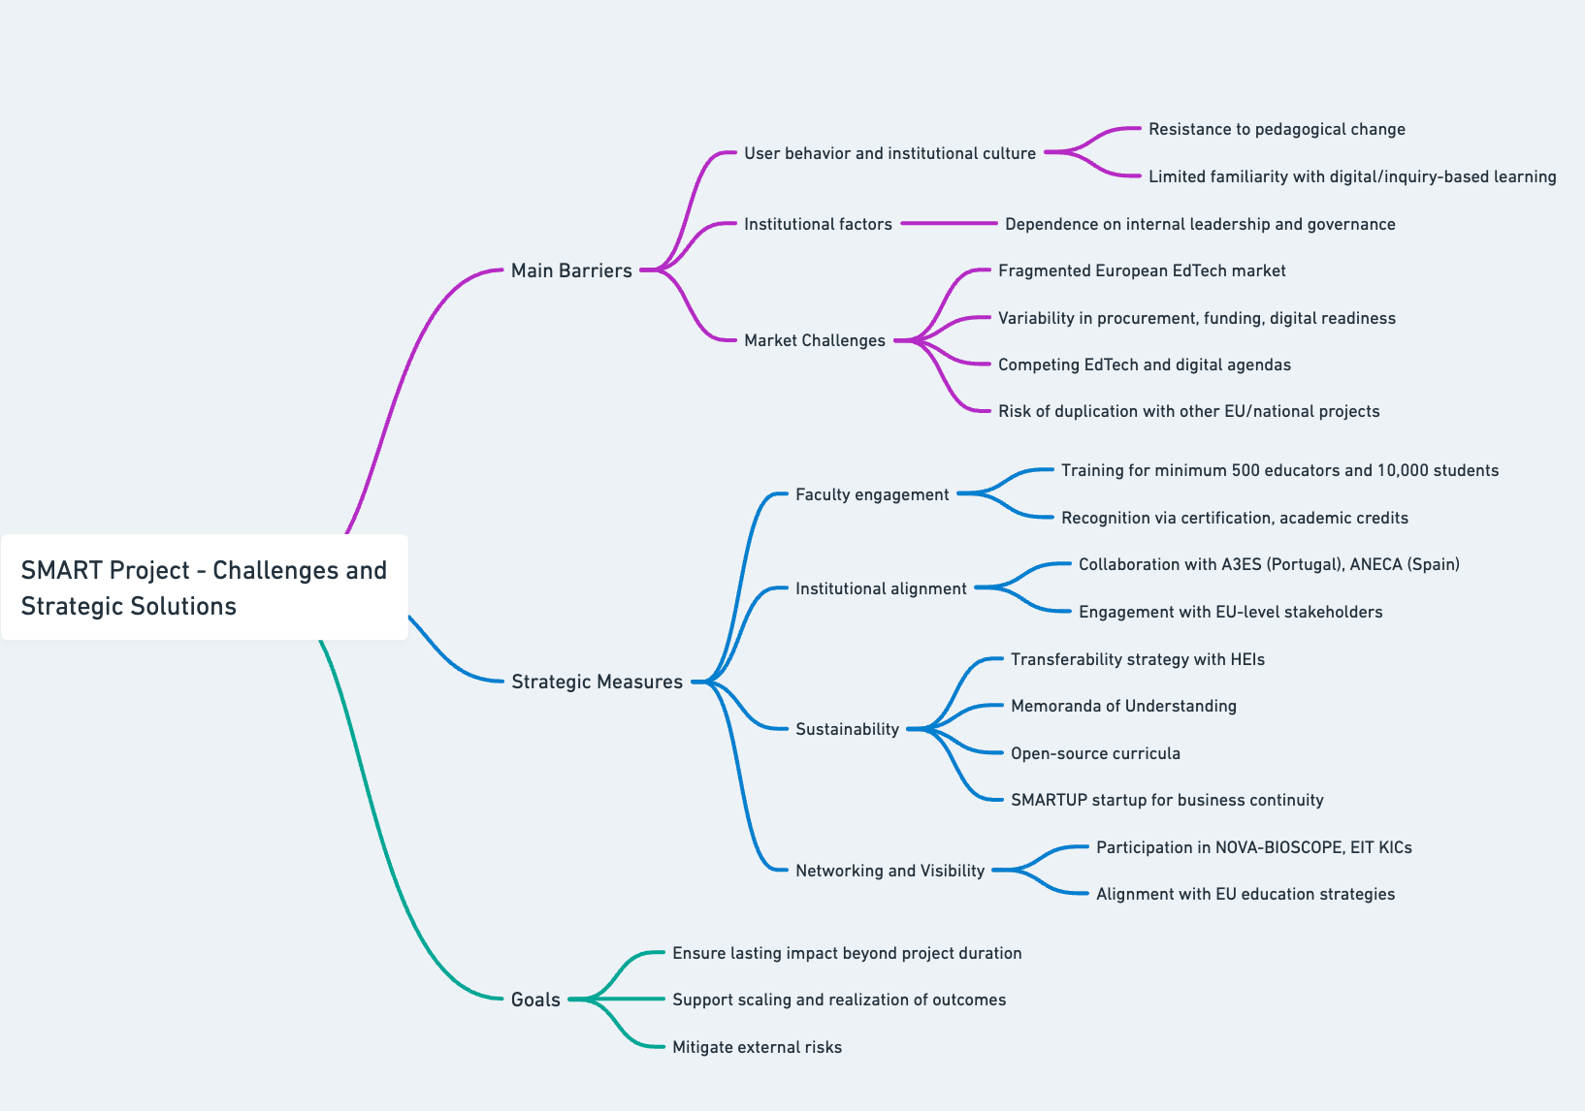

**2.2. Measures to maximise impact – Dissemination, exploitation and communication** #@COM-DIS-VIS-CDV@#

[e.g. 5 pages, incl. section 2.3]

**2.2.1 Dissemination, exploitation and communication**

* Describe the planned measures to maximise the impact of your project by providing a first version of your ‘plan for the dissemination and exploitation including communication activities’. Describe the dissemination, exploitation and communication measures that are planned, and the target group(s) addressed (e.g. scientific community, end users, financial actors, public at large).

*Please remember that this plan is an admissibility condition, unless the work programme topic explicitly states otherwise. In case your proposal is selected for funding, a more detailed ‘plan for dissemination and exploitation including communication activities’ will need to be provided as a mandatory project deliverable within 6 months after signature date. This plan shall be periodically updated in alignment with the project’s progress.*

*Communication*[1] *measures should promote the project throughout the full lifespan of the project. The aim is to inform and reach out to society and show the activities performed, and the use and the benefits the project will have for citizens. Activities must be strategically planned, with clear objectives, start at the outset and continue through the lifetime of the project. The description of the communication activities needs to state the main messages as well as the tools and channels that will be used to reach out to each of the chosen target groups.*

*All measures should be proportionate to the scale of the project and should contain concrete actions to be implemented both during and after the end of the project, e.g. standardisation activities. Your plan should give due consideration to the possible follow-up of your project, once it is finished. In the justification, explain why each measure chosen is best suited to reach the target group addressed. Where relevant, and for innovation actions, in particular, describe the measures for a plausible path to commercialise the innovations.*

*If exploitation is expected primarily in non-associated third countries, justify by explaining how that exploitation is still in the Union’s interest.*

*Describe possible feedback to policy measures generated by the project that will contribute to designing, monitoring, reviewing and rectifying (if necessary) existing policy and programmatic measures or shaping and supporting the implementation of new policy initiatives and decisions.*

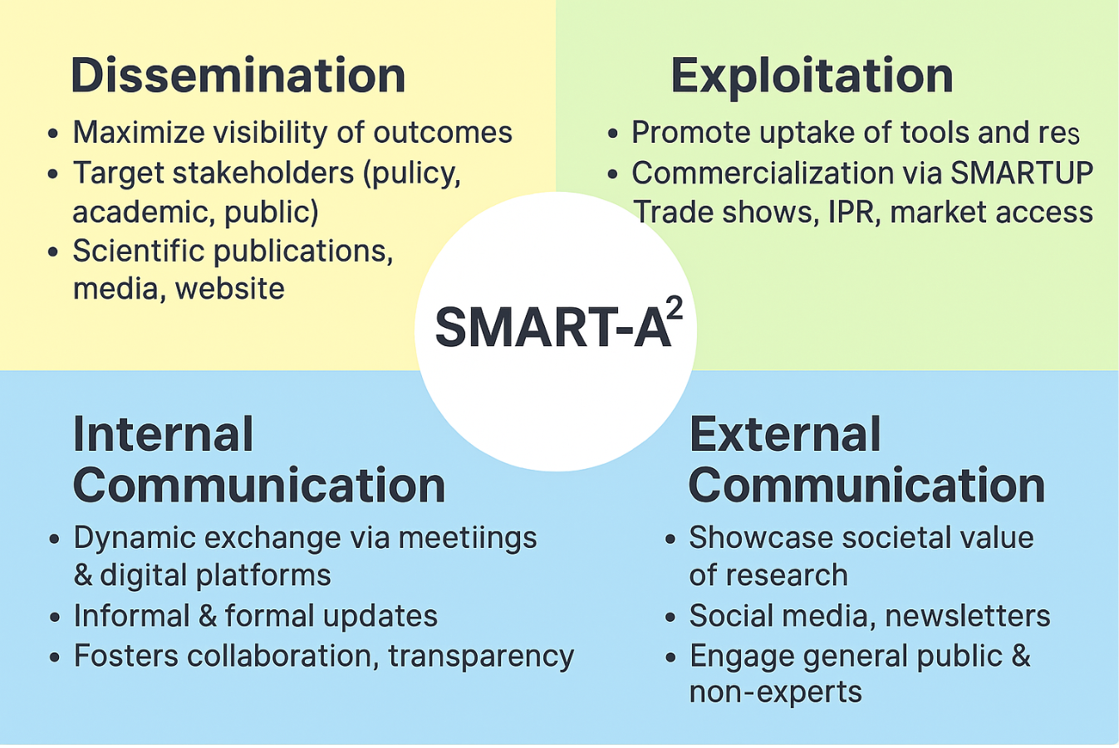

To ensure the maximum impact of the SMART**-A2** project, it is crucial to effectively communicate its findings to the relevant target audiences and stakeholders. This will be achieved through a comprehensive approach centered on dissemination, exploitation, and communication. EXEL, a highly experienced SME in managing high-profile EU research projects, will lead this effort, which is coordinated under a dedicated work package (WP4). The strategy is designed to foster awareness and engagement both during and after the project’s execution. A detailed plan outlining these activities will be prepared early in the project, specifying actions to enhance the project's visibility and reach.

**2.2.1.1 Internal Communication**

The **SMART-A2** consortium ensures continuous and dynamic communication through a variety of channels, facilitating the seamless exchange of information, insights, and updates. By drawing on the shared infrastructure and expertise of the Alliance of Alliances, like digital tools such as **virtual meetings**, **video conferencing**, andcollaborative **online platforms**, partners can engage efficiently across diverse locations and time zones. This communication framework integrates formal elements—such as the dissemination of official progress reports and documents—with informal interactions like **team chats**. This balanced approach fosters transparency and inclusivity, strengthening R&I human capital while improving collaboration across sectors.

To further promote cooperation and cross-sectoral collaboration, **SMART-A2** organises regular **consortium meetings**, both online and in person. These meetings are critical for deep discussions, problem-solving, and ensuring alignment with the project's overall objectives. Task-specific meetings are also scheduled to drive focused progress, particularly supporting the enhancement of excellence in Widening countries.

**2.2.1.2 Dissemination strategy**

The dissemination strategy for the **SMART-A2** project will be meticulously designed to ensure the effective communication of its results, discoveries, and achievements to a wide scientific audience and beyond. Aligned with the project’s goal of fostering institutional reforms, reversing brain drain, and enhancing knowledge circulation, this strategy will begin by identifying **key stakeholders** and developing **targeted approaches** to engage diverse audiences, including policymakers, industry leaders, academics, and the general public. Leveraging a mix of traditional and digital channels—such as press releases, academic publications, social media, and a dedicated **project website**—the plan aims to maximise the visibility and impact of **SMART-A2**’s outcomes.

Dissemination efforts will support key outcomes, including strengthening collaboration between academic and non-academic sectors, and improving private sector access to public R&I institutions and infrastructures. Key activities include: (1) Maintaining **SMART-A2**'s strong presence at relevant scientific and industry **forums**, **conferences**, and **symposia**, to showcase the project’s innovations and promote excellence in Widening countries; (2) Producing and distributing **newsletters**, **brochures**, and **infographics** to effectively communicate project progress and achievements to a wide range of stakeholders; (3) Engaging with the **media** to highlight **SMART-A2**’s contributions, increasing the project’s visibility across sectors and regions; and (4) Organising **workshops** and **webinars** to disseminate findings, enhance cross-sector collaboration, and promote entrepreneurial skills among participants. These comprehensive efforts aim to position **SMART-A2** as a driving force for impactful collaborations between academic and non-academic sectors, while enhancing the employability and career prospects of R&I talents. A detailed stakeholder engagement plan (part of D5.3) will ensure that the project’s findings are communicated effectively to the right audiences. To maximise impact, the commercial potential of results will be evaluated prior to publication, and all contributions from the EC will be duly acknowledged.

Additionally, **SMART-A2**’s results and tools will be presented at four major trade shows in the USA, Europe, and MENA, further strengthening the R&I base, promoting talent mobility, and improving career opportunities across both academic and non-academic sectors. Through these efforts, **SMART-A2** aims to leave a lasting legacy of knowledge, innovation, and capacity-building.

**Table 1: Indicative list of platforms for disseminating SMART-A2’s advancement**

| **International Conferences and Trade Shows** | **Scientific Journals** |
| --- | --- |
| International Caparica Conference on Science Education, 2025, 2027, 2029, 2031, 2033, 2035 | Review of Educational Research |
| International Caparica Conferences, Bioscope group 2026-2035 (already programmed, total of 57) | Journal of integrated OMICS (from Bioscope group) |
| NAFSA conferences. | Educational Researcher |
| The European Conference on Education | International Journal of Educational Technology in Higher Education |
| European Association for International Education series | Studies in Science Education |
| FENESP-Brazil | Talanta |
| FETC-USA | Communications Medicine |

**Table 2: List of stakeholders**

| **Stakeholder Groups** | **Identified entities** |
| --- | --- |
| Governmental institutions | National Ministries of Education via departments for High Education. National Research Councils and Innovation Agencies. Health Ministries and Health institutions. Introducing the SMART project at the K-12 level or in regional universities. |
| Regulators | National Agencies for Accreditation and Quality Assurance: <https://www.a3es.pt/> | <https://www.aneca.es> | <https://www.nvao.net/en> | https://www.qaa.ac.uk |
| Scientific community | STEM education specialists (Science, Technology, Engineering, Mathematics). Analytical and Bioanalytical Sciences Community. Biomedical Sciences Community. Physics and electrical engineers. Universities, medium schools. |
| Innovator community | Global innovation ecosystems like the **EIT KICs** (e.g., EIT Health, EIT Raw Materials). NGOs working on education accessibility in underserved areas. **Medium Schools.** |

**2.2.2.2 Communication Plan**

Through targeted and inclusive communication efforts, **SMART-A2** seeks to highlight the tangible impact of EU-funded research and innovation on everyday life. This strategy enhances knowledge circulation, strengthens public-private collaborations, and increases awareness of the societal value of research.

Table 3 outlines a comprehensive outreach plan designed to increase R&I support capacity, foster cross-sector collaboration, and engage the public and stakeholders. A strong digital presence and active use of social media will enhance visibility, while newsletters, press releases, and outreach materials will ensure continuous communication of the project's objectives and milestones. Scientific dissemination through conferences and publications will contribute to research excellence, while workshops and events will promote knowledge exchange and collaboration, supporting the balanced circulation of talent across sectors and regions.

**Table 3: Outreach Activities**

| **Activity** | **Description** | **Timing** | **Lead** | **Metrics** | **Target Audience** |
| --- | --- | --- | --- | --- | --- |
| **Digital Presence** | | | | | |
| Project Website | Central Hub for **SMART-A2** Updates and Resources. | From M3, ongoing | EXEL | >2000 visits/year | General public, researchers, stakeholders, medium schools |
| Social Media | Engage with updates on project platforms: Facebook, X, LinkedIn, and Instagram. | From M2, ongoing | EXEL | Followers: X: 1500; LinkedIn: 800; Instagram: 300 | General public, industry, policymakers, researchers |
| **Outreach Materials** | | | | | |
| Visual Identity | Designing of logo, letterhead, and presentation templates | M1 | EXEL | 5 templates | Consortium, stakeholders |
| Brochures & Leaflets | Distribution of detailed visuals about goals and benefits | M2, updated regularly | EXEL | 2 flyers, 2 roll-ups, 2 posters | Industry, policymakers, public, researchers |
| **Content Engagement** | | | | | |
| Newsletters | Distribution of electronic updates to stakeholders | Annually | EXEL | 4/year, >200 subscribers | Industry, policymakers, researchers, public |
| Press Releases | Highlighting significant milestones to the media | At major milestones | All | >5 releases | Media, general public, industry, policymakers |
| **Scientific Communication** | | | | | |
| Conferences | Sharing findings with the scientific community | After research results | All | 100 presentations | Researchers, industry experts, policymakers |
| Publications | Publishing findings in scientific journals | After research results | All | 20 publications | Researchers, academics, general public |
| **Events** | | | | | |
| Workshops, boot camps | Promoting **SMART-A2** and fostering collaborations | Annually | All | 80 workshops/boot camps | Researchers, industry, policymakers, public |
| Closing conference | Final event to share outcomes and enhance stakeholder interactions | M46 | NKUA | 1 conference | Researchers, policymakers, industry, general public |

**2.2.2.3 Networking and Training Activities**

To foster sustainable capacity-building and institutional integration of experiential STEM learning, the **SMART-A2** project embeds a structured program of networking and training activities. These efforts are strategically aligned with the international calendar of the NOVA-Bioscope group, which hosts recurring conferences across Europe through 2026 to 2035 and beyond (57 till 2035).

**Training Integration:**The project capitalizes on over six to seven annual international scientific conferences (at least 57 conferences in 10 years), <https://www.bioscopegroup.org/conferences/>, as real-world platforms for training a minimum of 300 educators in experiential pedagogy, digital tools, and inquiry-based learning (estimation of 5% of total conference attendees). Educators are invited to co-develop and present educational innovations, supported by academic recognition mechanisms (certificates, credits, and EU-level visibility).

In addition to in-person training, the project implements a comprehensive **online training framework** hosted through the **SMART-A2** Dr. VIDA website. This includes asynchronous modules, webinars, and virtual workshops on device usage, classroom integration, and assessment strategies. These resources ensure equitable access to training regardless of geographic location, promoting wide-scale adoption and institutional embedding. The web-based platform also supports continuous peer exchange, resource sharing, and tracking of certification progress.

**Networking for Impact and Visibility:**These conferences also serve as critical nodes for multi-level networking, enabling direct engagement with policy makers, institutional leaders, and EU education stakeholders. Through partnerships facilitated at these events, **SMART-A2** ensures alignment with university and medium school needs and synergies with Horizon Europe and EIT KIC initiatives.

**Sustainability through Community and Exchange:**By anchoring the project’s activities within the NOVA-Bioscope group, network until 2035, **SMART-A2** secures continuity for its community of practice beyond the formal funding period. This sustained engagement strengthens the project's institutionalization strategy and supports the international scaling of its educational model through the SMARTUP startup.

**2.2.2 IPR management**

Outline your strategy for the management of intellectual property, foreseen protection measures, such as patents, design rights, copyright, trade secrets, etc., and how these would be used to support exploitation.

*If your project is selected, you will need an appropriate consortium agreement to manage (amongst other things) the ownership and access to key knowledge (IPR, research data etc.). Where relevant, these will allow you, collectively and individually, to pursue market opportunities arising from the project.*

*If your project is selected, you must indicate the owner(s) of the results (results ownership list) in the final periodic report.*

**Protection Measures:** The project will adopt a hybrid intellectual property (IP) approach that balances openness and protection. Open-source licensing will be applied to educational protocols and non-commercial training materials, promoting accessibility and collaboration. At the same time, formal IP protection will be pursued for hardware design, software modules, and brand identity where appropriate. Specifically, the **Dr. Vida Education device**, including its hardware design and electronic components, will be protected through **utility models and/or design rights**, selected according to national and international patentability frameworks and cost-effectiveness. **Software components**, including the AI-driven data analysis interface, will be safeguarded by **copyright**, while the **core algorithms** may be maintained as **trade secrets** if deemed necessary. Furthermore, the project’s **visual identity**, encompassing the device’s branding and the digital interface, will be protected through **trademark registration** under the **SMARTUP** start-up entity. **Ownership and Consortium Agreement:** A comprehensive **Consortium Agreement (CA)** will be established prior to project launch, following the **DESCA model**. This agreement will clearly define **ownership of results and background knowledge**, establish **rules for joint ownership and access rights**—particularly where technical contributions are integrated—and outline **licensing options**, including non-exclusive rights for academic use and exclusive licenses for commercial exploitation. It will also specify **mechanisms for dispute resolution and revenue sharing**. Importantly, the CA will ensure that each consortium partner retains ownership of their **background IP**, while providing the necessary access rights to enable the **implementation and exploitation** of project outcomes. **Exploitation and Market Use:** The project’s exploitation strategy foresees the creation of a **start-up (SMARTUP)**, which will serve as the **commercialization and distribution vehicle** for the **Dr. Vida Education device**. All project results protected under IP frameworks will be **licensed or transferred** to this start-up under the conditions defined in the Consortium Agreement. In parallel, **open-access materials** such as curricula and experimental protocols will be made publicly available via a **dedicated online platform**, released under **Creative Commons licenses**. This approach guarantees wide societal access to educational resources while maintaining **brand visibility** and protecting the project’s reputation. **Results Ownership Reporting:** In accordance with **Horizon Europe IPR guidelines**, a detailed **Results Ownership List** will be submitted with the final periodic report, identifying the specific ownership of all project results. This reporting ensures transparency, post-project exploitation clarity, and full compliance with EU intellectual property requirements. This integrated and balanced IP management strategy guarantees that the innovations produced within the  **SMART-A2** project are **appropriately protected, openly accessible where feasible, and strategically positioned for long-term impact, sustainability, and societal benefit.**

#§COM-DIS-VIS-CDV§#

**2.3. Summary**

Provide a summary of this section by presenting in the canvas below the key elements of your project impact pathway and of the measures to maximise its impact.

**KEY ELEMENT OF THE IMPACT SECTION**

| **SPECIFIC NEEDS** | **EXPECTED RESULTS** | **D & E & C MEASURES** |
| --- | --- | --- |
| *What are the specific needs that triggered this project?*  Many higher education institutions, particularly in Widening regions, lack affordable and scalable laboratory equipment that enables hands-on science training. This structural gap severely limits student engagement, reduces the effectiveness of STEM education, and prevents the consistent integration of experiential learning into curricula. A critical unmet need is the **“one-student-one-apparatus”** model, which ensures that each student has direct, individual access to experimental tools. Without this, learning becomes passive and observational, reinforcing educational inequalities and hindering the development of practical and analytical skills essential for scientific literacy and employability. | *What do you expect to generate by the end of the project?*  By 2030, the project expects to have trained **10,000 students** and **a minimum of 500 educators** worldwide (Alliance of Alliances), and to have fully institutionalized the Dr. Vida Education approach in at least **49+4+10 higher education institutions (HEIs)**. In addition to these quantitative outcomes, the project aims to foster a **paradigm shift in science education**—transforming traditional teaching practices by integrating **in situ, hands-on experimentation** directly into theoretical classes and to share teachers´ knowledge. This model encourages active learning, enhances conceptual understanding, and bridges the gap between abstract knowledge and real-world application. Furthermore Dr. Vida education will have a second line of utility by multiple tasks (health, environment) in widening and or remote areas. | *What dissemination, exploitation and communication measures will you apply to the results?*  **Exploitation**: The Dr. Vida Education device will be commercialized through a dedicated spin-off company (SMARTUP), with protection ensured via design rights and utility models. Licensing options will be offered to higher education institutions. Open-source curricula and lab protocols will be published under Creative Commons to support wide, non-commercial use. **Dissemination**: Results will be shared via peer-reviewed publications, international conferences (e.g., SEFI, EARLI, EIT summits), and regional educator workshops. Policy briefs will be submitted to accreditation bodies (e.g., A3ES, ANECA), and outcomes will be promoted through the NOVA-BIOSCOPE network, EU platforms, and Horizon Europe clusters. **Communication towards citizens**: The project will run outreach campaigns via its website ([**www.smartupdreducation.eu**](http://www.smartupdreducation.eu)) and official social media channels, including **YouTube**, **Instagram**, **LinkedIn**, Facebook and **X**. Activities will include public demonstrations at science festivals, school engagement events, and short video documentaries highlighting student impact and real-life experimentation. |
| **TARGET GROUPS** | **OUTCOMES** | **IMPACTS** |
| *Who will use or further up-take the results of the project? Who will benefit from the results of the project?*  **In addition to EHI beneficiaries of with this project the following ones:** Alliances totalling 49+4+10 universities: EUTOPIA, EPICUR, CIVIS, UNA Europa, SEA-EU + Brazilian Universities (10). Universities and Medium Schools all over the world via access to the web page and to share hands-on and knowledge. | *What change do you expect to see after successful dissemination and exploitation of project results to the target group(s)?* The *Alliance of Alliances*—uniting networks like EUTOPIA, EPICUR, CIVIS, UNA Europa, and SEA-EU—amplifies the reach of the SMART Dr. VIDA project across Europe. At least 45 higher education institutions, especially in Widening countries, are expected to adopt the Dr. VIDA device and protocols, embedding hands-on experimentation into science education. This supports the broader uptake of a“one-student-one-device” model, influencing STEM pedagogy, curricula, and teacher training. At the same time, SMART Dr. VIDA advances EU goals in sustainability and citizen science by enabling students to conduct real-time experiments on environmental and public health topics. By connecting learning with real-world issues, the project fosters scientific literacy and environmental awareness, helping build more resilient communities across Europe. | *What are the expected wider scientific, economic and societal effects of the project contributing to the expected impacts outlined in the respective destination in the work programme?* **Scientific:** SMART Dr. VIDA delivers a scalable, evidence-based model for integrating hands-on experimentation into STEM education, validating the “one-student-one-device” approach. **Economic/Technological:**  By commercialising a modular, low-cost teaching device and launching a dedicated startup, the project strengthens the EU EdTech ecosystem, boosts innovation, and supports job creation in high-tech education sectors. **Societal:**  It enhances science literacy and digital competence among teachers and students—particularly in Widening countries—by ensuring inclusive access to advanced learning tools. The project supports equitable, gender-balanced participation in STEM and empowers underserved communities through democratized, real-world science learning. It aligns with the Sustainable **SDG 4 (Quality Education)**, **SDG 5 (Gender Equality)**, **SDG 10 (Reduced Inequalities)**, and **SDG 13 (Climate Action)**, by fostering a generation of informed, and socially engaged citizens. |

**3. Quality and Efficiency of the implementation** #@QUA-LIT-QL@# #@WRK-PLA-WP@#

**3.1. Work plan and resources**

**Table 3.1a – List of work packages**

| **WP No** | **WP Title** | **Lead Participant No** | **Lead Participant Short Name** | **Person Months** | **Start Month** | **End Month** |
| --- | --- | --- | --- | --- | --- | --- |
| 1 | **Foundation and Implementation** | 1 | NOVA |  | 1 | 60 |
| 2 | **Expansion and Global Impact** | 9 | UPE |  | 12 | 60 |
| 3 | **Educational Research** | 2 | UNIBO |  | 3 | 60 |
| 4 | **Dissemination, Outreach and Exploitation** | 6 | EXEL |  | 1 | 60 |
| 5 | **Project Management** | 1 | NOVA |  | 1 | 60 |

***PERT chart***

**Table 3.1b – Work package description**

| **Work Package number** | **1** |
| --- | --- |
| **Work Package title** | **Foundation and Implementation** |
| **Objectives:** WP1 focuses on **implementing the Dr. VIDA Education device into pilot curricula** across eight participating academic institutions, engaging by the end of 2026 over 800 students and 24 teachers in eight hands-on laboratory modules that integrate real-time data collection and analysis into STEM teaching (all beneficiaries). This rollout serves as a foundation for evaluating pedagogical effectiveness and institutional integration of Alliances. Concurrently, the project initiates the **development of an advanced prototype** of the Dr. VIDA device (STABV) featuring a **touchscreen interface** and **UV detection capabilities, in addition to a calibration system (KNU)**. This next-generation system is designed to expand experimental possibilities in health and environmental monitoring, while enhancing usability for both students and educators in field and classroom contexts. | |
| **T1.1 – Digital transformation of Dr. Vida and Green Lab Learning [M1-21] (Lead**: NOVA; Contributing: ​​STABV, UNIBO, UNICAMP, UPE, UOA, UHU, EXEL,YAGHMA**)** | |
| As part of the SMART-A² initiative, and powered by the Alliance of Alliances, this phase of the project focuses on finalizing the Dr. Vida Education device, transforming the current prototype into a fully operational, screen-based digital tool. This shared effort is driven by the consortium’s diverse institutional strengths and educational traditions, fostering collaborative innovation across borders. In parallel, the project will redesign and harmonize eight laboratory practices based on green bioanalytical minimalism—a framework that reduces reagent use and minimizes environmental impact. These carefully selected, hands-on experiments will include: (i) total protein quantification in urine for kidney disease detection, and (ii) for myeloma disease, (iii) extraction and analysis of mercury in water, and (iv) arsenic in water, (v) bacterial contamination in water, (vi) lactose intolerance detection, (vii) Salmonella detection, and (viii) legionella detection. Together, these practices offer an interdisciplinary, real-world learning experience in health and environmental science. **Crucially, all members of the Alliance of Alliances—spanning Europe, Brazil, and Africa—will actively exchange skills and methodologies through staff mobility, becoming mutual trainers and testers**. This model ensures that each institution not only teaches but also learns from the others, reinforcing peer-to-peer innovation across the alliance. The finalized version of the Dr. Vida device will integrate a comprehensive description of all eight lab practices, including statistical tools; an open-source digital interface that guides both teachers and students through experiments and data interpretation; structured questionnaires and AI-driven self-assessment tools to enhance reflection and pedagogical feedback. By embedding AI into both experimental guidance and student evaluation, SMART-A² ensures that educational innovation is both scalable and personalized. The Alliance of Alliances thus becomes the foundation of a co-created, sustainable, and pedagogically rich STEM learning ecosystem—fostering scientific literacy, green practices, and institutional reform across regions. **(D1.1a, D1.1b)** | |
| **T1.2 –Evaluating Learning Outcomes of Dr. Vida-Enabled Lab Activities Across Institutions [M1-27] (Lead**: **YAGHMA**, Contributing: UNIBO, UNICAMP, UPE, UOA, UHU**)** | |
| Focuses on testing and validating the laboratory activities developed in Task 1.1 in practical classes, targeting 1500 students across the eight academic beneficiary institutions. Statistical analyses will be conducted to evaluate student success across the projects and institutions. Techniques include descriptive statistics, ANOVA, regression models, and machine learning to identify performance patterns and predictors. This comprehensive framework will assess the device's impact on learning outcomes and provide data-driven insights to refine educational practices, ensuring the success of the pilot phase and laying the foundation for broader implementation. **(D.1.2).** | |
| **T1.3 – Task title: Creating SMARTUP start up to Lead in Educational Technology [M1-60] (Lead: NOVA,** Contributing: UNIBO, UNICAMP, UPE, UOA, YAGMA**)** | |
| The establishment of the SMARTUP startup, centred around the Dr. Vida Education device, represents a transformative step toward modernizing science education. Aims to develop an innovative, scalable, and adaptable solution that promotes personalized learning, enhances student engagement, and integrates digital tools across multiple educational levels by integrating teacher´s interaction. A dedicated PhD researcher will be recruited to lead research and development activities, assess the device's pedagogical effectiveness, and ensure its alignment with evidence-based educational methodologies. This role will encompass data-driven optimization of the device, integration into curricula, development of intellectual property strategies, and international networking to position **SMARTUP as a reference in educational technology and learning among EU and Brazilian HEIs. Beyond 2030, the PhD and consortium partners will spearhead the global expansion of SMARTUP, utilizing opportunities such as the Europe-Mercosur treaty to reach broader educational markets and foster cross-continental collaboration via staff mobility. (D.1.3)**. | |

| **Work Package number** | **2** |
| --- | --- |
| **Work Package title** | **Expansion and Global Impact** |
| **Objectives:** The second phase scales the adoption of Dr. Vida Education approach to the members of the alliances: Each beneficiary will engage in the project up to 2 national HEIs collaborators integrated in the Alliances taking part in this study, targeting a minimum of 3 teachers and 125 students per HEI (a minimum of 2000 students, 16 HEIs + 48 educators). **The final phase institutionalizes the Dr. Vida Education program across the other 39 HEIs** (completing the list of 49+4+10 HEIs involved in this alliance, at least 10000 students and at least 200 teachers, including Brazil). (See Table E). Key activities include the following tasks: | |
| **T2.1 – Task title: 1st expansion. Expanding Dr. Vida education to further HEIS [M13-36] (Lead: UPE;** Contributing: NOVA, UNIBO, STABV, UOA, EXEL, UNICAMP, YAGHMA, KNU, UHU) | |
| Engaging a total of 16 HEIs and a total of 48 educators and at least 2000 students. These educators will be trained in the laboratories of their respective national beneficiaries or via the internet (e.g.: Zoom). **(D.2.1). (See table E).** Each beneficiary engages 2 national HEIs. A significant checkpoint will be the agreement of 16 HEIs to implement the Dr. Vida Education approach. | |
| **T2.2 – Development of web based tools [M17-30] (Lead: YAGHMA;** Contributing: UNICAMP, UNIBO, STABV, UOA, EXEL, UNICAMP, KNU, UHU, UPE**)** | |
| Development of web-based tools in the **SMART Dr. VIDA EDUCATION** web page so the practices developed in work package one and the statistics results are available to the Alliance of Alliances' educational community and world wide. **(D2.2)** From month 1 to 2 we’ll sit with research managers, librarians and researchers to turn policy goals (open science and fairer research assessment) into simple user journeys. From month 2 to 6 we’ll build the first version and connect it to each university’s existing systems (e.g., log in once with your university account, pull in your ORCID profile, push deposits to your repository). Between months 6 and 10 we’ll run two pilot rounds at a minimum of four universities—at least two in Widening countries—to fix usability issues, tighten security and make the workflows faster. By months 11–12 we’ll release a beta, hand over an admin guide and API notes, and train local support staff so they can run it without us. By the end of the year, researchers will be able to record contributions for narrative CVs, deposit publications/data/software in one guided flow, and register and track small seed projects end-to-end—with clear audit trails. We aim for active use in four universities, at least 200 outputs deposited, and smooth single sign-on everywhere. The main risks are slow IT integrations, low initial uptake and privacy concerns; we manage these with early test environments, co-design and a data-protection impact assessment from the start. All AI-enabled features of the web-based tools—such as automated feedback, quality checks and simple learning analytics—will follow the robustness principles outlined in Section 1.2.1, ensuring reliability, transparency, and proportional risk management throughout development. | |
| **T2.3 – Learning Innovation Boots Camps [M14-60](Lead: NOVA**; Contributing: UNICAMP, UNIBO, STABV, UOA, EXEL, UNICAMP, YAGMA, KNU, UHU, UPE**)** | |
| Launching innovation boot camps aims to train a minimum of 500 educators across Europe and South America linked to the Alliance of alliances, thus stimulating staff mobility. From 2027 to 2030, two boot camps will annually be done by each beneficiary institution (48 in total, three days each, 5 participants minimum per camp). These immersive programs equip teachers and technical staff with skills to integrate the Dr. Vida Education device and modern teaching methodologies, enhancing student engagement and personalized learning. The curriculum covers innovative pedagogy (information developed in task 1.2), technology adoption (Dr. Vida implementation), and practical applications (The 8 practices developed in task 1.1), thus fostering a network of educators as ambassadors for Dr. Vida Education. This ensures scalability and sustainability by embedding these tools into everyday teaching, bridging traditional and modern education for lasting impact. **(D.2.3).** | |
| **T2.4 – 2nd Expansion. Expanding Dr. Vida to the Alliance of Alliances [Task Duration: M34-60] (Lead: UNIBO**; Contributing: UNICAMP, NOVA, STABV, UOA, YAGMA, KNU, UHU, UPE**)** | |
| This task focuses on fostering teaching and learning innovation by embedding the device into core curricula and promoting active interchange of pedagogical practices among partner institutions. It emphasizes alignment with degree accreditation standards to ensure sustainability and meaningful institutional integration in the remaining Alliance of Alliances´ HEIs (at least 10 teachers per institution, minimum of 500 educators, minimum of 10000 students) and new HEIs worldwide, advancing the dissemination of the Dr. Vida device and concept. Deliverables include collaborative curriculum integration plans, shared training resources, implementation data, accreditation documentation, and pilot results, all made publicly available on the project webpage to support transparency, peer learning, and broad educational engagement **(D2.4).** (See table E). | |

| **Work Package number** | **3** |
| --- | --- |
| **Work Package title** | **Educational research** |
| **Objectives:** (i) To assess the pedagogical effectiveness of the eight experimental laboratory activities developed around the Dr. Vida portable device. To evaluate the impact of interdisciplinary, hands-on experimentation on students’ conceptual understanding, scientific reasoning, digital skills, and engagement. To generate evidence-based insights into how low-cost, modular lab instrumentation can enhance science education across multiple educational levels and disciplinary contexts. To contribute to broader European educational innovation and inclusivity agendas through open educational resources and longitudinal studies. (ii) To Design a quality control and calibration system for the Dr. Vida device. | |
| **T3.1 – Design of Educational Research Methodology [M4-23] (Lead: UNIBO**; Contributing: NOVA, STABV, UNICAMP, UPE**)** | |
| This task will define the framework for evaluating the educational impact of the Dr. Vida-based practices. It will involve: Definition of research questions and hypotheses (e.g., How does modular instrumentation affect learning and engagement?). Development of validated quantitative and qualitative instruments, including: (i) Pre/post surveys for students and educators, (ii) Self-assessment tools. (iii) Focus group protocols. (iv) Engagement and interdisciplinarity rubrics. (v) Ethical approvals and GDPR-compliant data protocols. (**D3.1**). | |
| **T3.2 – Data Collection During Educational Activities [M13-60] (Lead: UNIBO**; Contributing: NOVA, STABV, UNICAMP, UOA, YAGHMA, KNU, UHU, UPE) | |
| While the scientific focus of the experiments is not the subject of this Work Package, they serve as the context for measuring: teachers and Student engagement and confidence in scientific practice. Perceived relevance and interdisciplinarity. Ability to apply knowledge to real-world problems. Collaborative learning and use of digital tools (e.g., Python, AI models) (**D.3.2**) | |
| **T3.3 – Analysis of Learning Outcomes and Skill Acquisition [M16-60] (Lead: UNIBO;** Contributing:NOVA, STABV, UNICAMP, UOA, YAGHMA, KNU, UHU, UPE**)** | |
| Collected data will be analyzed to assess: Conceptual understanding (before/after). Development of soft and hard skills (critical thinking, data interpretation, coding). Influence of disciplinary background (e.g., bioinformatics vs. medicine vs. engineering). Differences across educational levels or countries. Quantitative data (survey scores) will be statistically analyzed; qualitative data (focus groups, open comments) will undergo thematic coding. Insights will inform both practice improvement and scholarly dissemination. **(D.3.3)** | |
| **T3.4 – Long-Term Educational Impact and Resource Development [M39-60] (Lead: UNIBO;** Contributing:NOVA, STABV, UNICAMP, UOA, YAGHMA, KNU, UHU, UPE**)** | |
| This task will extend the educational evaluation beyond immediate outcomes to examine the long-term effects of the Dr. Vida-based experimental activities. A longitudinal study will track selected learners and educators over time to evaluate: Retention of scientific concepts and interdisciplinary thinking. Continued engagement with experimental science and data analysis. Influence on teaching practices, curriculum development, and learner pathways. Institutional-level reflections on the integration of low-cost, modular lab devices. In parallel, this task will synthesize insights from the entire Work Package to produce tangible, shareable educational outputs, including: A repository of Open Educational Resources (OERs) linked to the eight experimental activities, annotated with pedagogical guidance, survey-informed modifications, and multilingual support. Policy briefs and recommendations for stakeholders (educators, curriculum developers, ministries, EU-level actors) on how to implement affordable digital science tools to foster interdisciplinarity, inclusivity, and hands-on learning in STEM. These outputs will ensure that the project’s findings are scalable, transferable, and impactful across European education systems and beyond. **(D.3.4)** | |
| **T3.5 – Development of calibration algorithms and internal QC materials and Prototype integration of calibration system into Dr. Vida platform [M13-36] (Lead: STABV**; Contributing: NOVA, UNIBO, KNU, UNICAMP, UOA, YAGHMA, UHU, UPE**)** | |
| Development of algorithmic calibration protocols using digital standards and reference materials. Design of synthetic QC templates for CMV and ZIKA to ensure reproducibility of qLAMP results across devices and sites. Hardware and software integration of calibration module into the device. Testing of automatic calibration routines under laboratory conditions. **(D3.5.).** | |
| **T3.6 – Multicenter validation of calibration system and Final calibration guidelines and SOPs [M30-47] (Lead: UNIBO**; Contributing: NOVA, STABV, UNICAMP, UOA, YAGHMA, UHU, UPE**)** | |
| Deployment of prototype calibration-enabled Dr. Vida devices in academic beneficiaries. Evaluation of reproducibility, stability, and robustness of calibration across environments. Assessment of inter-laboratory comparability and calibration performance. Compilation of calibration protocols, QC material specifications, and SOPs for integration into the device manual and regulatory documentation. **(D3.6).** | |

| **Work Package number** | **4** |
| --- | --- |
| **Work Package title** | **Dissemination, outreach and exploitation** |
| **Objectives:** Raise the visibility of SMART and highlight its contributions to advancing systemic approaches in multiomics research, cutting-edge technologies, and the professional development of researchers operating in challenging environments; disseminate innovative scientific results, datasets, workflows, and applications across healthcare, education, and industry sectors; and maximise scientific and societal impact by effectively communicating project knowledge, standards, and outcomes both during and beyond the project’s implementation period. | |
| **T4.1 – Dissemination Plan to Reach the Scientific Community and Policymakers [M1–48] (Lead: EXEL;** Contributing:All) | |
| SMART will ensure strategic and targeted dissemination to both the scientific community and policymakers through coordinated communication, stakeholder engagement, and adaptive outreach strategies. Key actions include: Audience Identification: Define and engage primary audiences, including researchers, healthcare professionals, SMEs, higher education institutions, and policymakers. Interactive formats—such as focus groups, workshops, and joint discussions—will be used to gather feedback, foster collaboration, and align research outcomes with policy and practice. Specifically: For researchers: Showcase scientific innovations, methodologies, datasets, and detailed project results. For policymakers: Highlight actionable insights, societal relevance, and implications for evidence-based policy and decision-making.Communication Channels: Disseminate open-access articles and reviews in high-impact journals, present project results at conferences, symposia, and policy panels, and share preprints via platforms such as ResearchGate, Google Scholar, and institutional repositories. Online Presence: The project website will serve as a central hub for news, publications, and open-access materials. Active engagement on social media channels (LinkedIn, X, YouTube) and via newsletters will further extend reach and interaction. Feedback and Interaction: Implement two-way communication mechanisms to collect input from scientific and policy communities, ensuring responsiveness and continuous improvement of dissemination practices. **(D4.1, D4.3, D4.4)** | |
| **T4.2 – Communication strategy [M1-60] (Lead:** EXEL, Contributing: All**)** | |
| **This task focuses on civil society. Communication strategy.** The communication activities of the SMART project will be ongoing throughout its duration aiming at engaging the citizens. It will include the following elements: **(1) Communication Plan**: Develop a comprehensive plan outlining milestones, deliverables, and events, utilising channels like email newsletters, the project website, and social media for targeted outreach; **(2) Mailing Lists**: Add a subscription tool to the website, allowing medium schools to sign up for newsletters and public updates, ensuring continuous engagement; **(3) Visual Communication**: Use infographics, charts, and diagrams to present complex information in a clear, accessible way for various audiences; **(4) Engaging Communication Material**: Create a presentation video; Release press announcements and newsletters; Develop fact sheets, a project brochure, and a teacher-focused brochure on screening, hands-on, and advocacy; **(5) Feedback and Review**: Regularly assess the effectiveness of communication efforts and adjust based on stakeholder input; **(6) Cross-Sector Collaboration:** Promote interdisciplinary cooperation to ensure that project outputs align with policy and industry needs. **(D4.3, D4.4)** | |
| **T4.3 – Exploitation strategy [M1-60] (Lead beneficiary:** EXEL, Contributing: All**)** | |
| At the start of the project, a Data Management Plan (DMP) will be established to ensure efficient utilisation and long-term sustainability. In the initial phases, an internal innovation survey will be conducted using structured questionnaires to clearly identify exploitable outcomes and assess their Technology Readiness Level (TRL). Additionally, a Total Available Market (TAM) analysis of SMART application fields will be conducted. Throughout the project's duration, ongoing monitoring of new funding opportunities in national and European call for all partners will be undertaken. **(D4.2, D4.3, D4.5)** | |

| **Work Package number** | **5** |
| --- | --- |
| **Work Package title** | **Project Management** |
| **Objectives:** Oversee the attainment of scientific objectives in alignment with the project plan; Administer financial, administrative, and legal aspects with full transparency; Promote efficient communication among partners and with the European Commission; Ensure the timely preparation and submission of progress reports in accordance with the project timeline; Provide organisational and logistical support for consortium meetings and related activities. | |
| **T5.1 – Technical and Day-to-day management [M1-60] (Lead beneficiary: NOVA;** Contributing beneficiaries: All**).** | |
| NOVA will oversee the day-to-day and technical management of SMART. This includes defining detailed work plans, briefing staff on contractual obligations, and monitoring budget and effort distribution. The management team will regularly assess risks, implement corrective measures when necessary, and maintain an up-to-date Project Management Handbook. Effective communication will be ensured through teleconferences, as well as virtual and in-person meetings, enabling continuous monitoring of scientific and technical progress, training activities, and results. NOVA will ensure compliance with contractual obligations, manage amendments when required, and submit financial reports on time, supported by appropriate cost justifications to the European Commission. The team will also coordinate the allocation of EC funds to partners, track budget implementation, and assist partners with financial and administrative matters. A contingency plan will be maintained and periodically updated, with presentations at each consortium meeting to foster proactive risk management.**(D5.1)** | |
| **T5.2 – Meeting organisation and following up [M1-60] (Lead beneficiary: NOVA**, Contributing beneficiaries: All**).** | |
| EXEL will coordinate, organise, and manage all follow-up activities for project meetings, including the kick-off, General Assembly, Steering Committee, and ad hoc Advisory Board meetings. Responsibilities encompass: setting clear objectives for each meeting and communicating them in advance; preparing and distributing detailed agendas with time allocations for each topic; overseeing logistical arrangements for both virtual and in-person meetings, including venues, equipment, catering, and IT support; drafting and circulating comprehensive minutes summarising decisions, actions, responsibilities, and deadlines; and maintaining a centralised repository for all meeting materials, including documents, presentations, and attendance records. **(D5.2)** | |
| **T5.3 – Consortium agreement[M1-4] (Leader: NOVA;** Contributing: All) | |
| Consortium Agreement. NOVA will ensure that all project activities adhere to ethical standards and the European Commission’s gender equality policy. Partners will receive training on ethical and gender-related requirements, with detailed guidance provided in a dedicated section of the Project Management Handbook and on the project website. Key actions include: developing and maintaining ethical guidelines, supported by regular awareness and training sessions; implementing a systematic process to assess ethical risks and update assessments as needed; ensuring secure data management, anonymisation of sensitive information, and compliance with relevant data protection regulations; integrating gender equality principles into all project activities, including team composition, participation, and decision-making; promoting diversity and inclusion across all project teams; and establishing a monitoring and reporting framework for ethical and gender-related issues, including confidential reporting channels and periodic analyses to identify and address potential concerns. **(D5.3)** | |

***Gantt chart***

#### 

Find it here:

| **Total Protein Quantification in Urine.** Teachers andStudents will develop **hands-on** expertise in protein quantification techniques, including colorimetric assays (e.g., Bradford method) and spectrophotometry, with a focus on sample preparation, assay optimization, and ensuring accuracy and reproducibility. They will gain experience in modern laboratory instruments, integrating digital tools for data analysis and interpretation, and using **Python programming for data visualization and AI-driven insights.** Skills include calculating protein concentrations, constructing calibration curves, and performing statistical validation to ensure precision and reliability. Interdisciplinary learning will link urinary protein levels to clinical conditions such as **myeloma and kidney disease (synthetic urine, large metadata for Myeloma and Kidney diseases applications). At the Master’s level,** the project will scale to advanced proteomic techniques, utilizing high-resolution mass spectrometry for detailed protein profiling and integrating protein quantification with metabolomics for systems-level insights. High-throughput adaptations will support large-scale epidemiological studies and point-of-care diagnostic tool development, equipping teachers and students with skills to advance clinical diagnostics, biomedical research, and public health. Core manuscripts: https://doi.org/10.1016/j.talanta.2024.126589, [*https://doi.org/10.1038/s43856-023-00238-4*](https://doi.org/10.1038/s43856-023-00238-4)Developers: UPE and YAGHMA. Testers: UNIBO, UNICAMP, KNU, UHU, NOVA, STABV, and UOA. Biostatistics: UOA |
| --- |
| **Fluorescence.** Using organic probes, Hg, As and bacteria will be determined in fortified water samples, teachers and students will be introduced to toxicology, environmental issues, and healthcare topics related to drinking water and wastewater. The same technique will be applied to highlight the importance of bacterial detection and the classification of bacteria as Gram-positive or Gram-negative. This will also introduce students **to the One Health approach** and the topic of antibiotic resistance.Students will develop **hands-on** expertise in solid-liquid phase microextraction techniques and cloud point extraction for analyte preconcentration. They will learn to integrate digital imaging into analytical workflows, optimizing parameters for reproducibility and precision with small sample volumes. Skills include **quantitative analysis** (concentration calculations, LOD/LOQ, calibration curves) and statistical validation for reliable results. Programming and data visualization using Python, along with AI techniques, will enhance imaging result interpretation. Technology integration emphasizes using mobile devices and Dr. Vida Education for portable, accessible solutions, as well as automating experimental setups for real-time data acquisition. Interdisciplinary learning will cover the toxicological impacts of Hg and As on food safety, public health, and environmental systems. **At the Master’s level,** the project scales to advanced techniques, including high-resolution and tandem mass spectrometry for precise identification and quantification, and explores the interaction Hg and As with biological systems through medical and environmental proteomics. **This comprehensive approach prepares teachers** for addressing food safety and environmental health challenges. Core manuscript: <https://doi.org/10.1016/j.jhazmat.2024.136107>. Developers: UHU, UNICAMP, UNIBO and YAGHMA. Testers: UPE, KNU, NOVA, STABV and UOA. Biostatistics: UOA |
| **PCR Diagnostics for Public Health: Lactose Intolerance, salmonella and legionella determination in water..** Teachers andStudents will gain **hands-on** expertise in molecular biology techniques such as **PCR setup, DNA/RNA extraction,** and gel electrophoresis for product verification. They will learn to operate and optimize **PCR thermocyclers,** analyze real-time PCR data, and apply automation through programming. Skills include quantitative analysis (Ct values, LOD/LOQ), statistical validation (sensitivity, specificity), and Python-based bioinformatics for PCR data processing, enhanced by AI integration for diagnostics. The project emphasizes interdisciplinary learning, covering public health implications of PCR in disease surveillance, epidemiology, and environmental health monitoring. Students will explore high-throughput PCR for large-scale studies, multiplex PCR for co-infection detection, and advanced applications like integrating proteomics and mass spectrometry (e.g., MALDI-TOF). **Scalable diagnostic** workflows for outbreak response and portable diagnostic kits will address critical issues like antimicrobial resistance and environmental health monitoring, preparing teachers and students for impactful roles in public health diagnostics. Core manuscripts: <https://doi.org/10.1093/jalm/jfad052>; https://doi.org/10.1128/spectrum.01271-24; https://doi.org/10.2166/ws.2022.240 Developers: NOVA, STABV, KYIV and YAGHMA. Testers: UNIBO, UPE, KNU, UHU, and UOA. Biostatistics: UOA |

**TABLE E.** Academic beneficiaries and expected future partners.

| The comprehensive list of 63 (49+4+10) universities includes: (i) core 8 HEIS (Academic beneficiaries); the 45 universities included in the Alliance of Alliances as presented in 1.1, and the following Brazilian universities; University of São Paulo, Federal University of Rio de Janeiro – UFRJ, Federal University of Minas Gerais – UFMG, São Paulo State University – UNESP, Federal University of Rio Grande do Sul – UFRGS, Federal University of Santa Catarina – UFSC, Federal University of Paraná – UFPR, University of Brasília. |
| --- |
|
|
|

**Table 3.1c: List of Deliverables**

| **No** | **Deliverable Name** | **Short Description** | **WP No** | **Short Name of Lead Participant** | **Type** | **Dissemination Level** | **Delivery Date**  **(In Months)** |
| --- | --- | --- | --- | --- | --- | --- | --- |
| D1.1a | Final prototype | Dr. Vida education digital | 1 | STABV | DEM | SEN | 15 |
| D1.1b | hands-on instructional guides | Instructions to implement Dr. Vida at the laboratory | 1 | NOVA | R | PU | 21 |
| D1.2 | Preliminary learning outcomes | Educational research targeting 500 students | 1 | UOA | R | PU | 27 |
| D1.3 | Presenting the educational startup SMARTUP | Creation of SMARTUP Startup to support the project | 1 | UNL | R | SEN | 20 |
| D2.1 | 1st expansion. | 48 educators trained for the Dr. Vida Education device, hands-on works and statistics. 2000 students. + 16 HEIS | 2 | UPE (replacement UNIBO) | DEM | PU | 36 |
| D2.2 | Development of web-based tools | Tools related to the experimental practices. | 2 | YAGHMA | DEC | PU | 30 |
| D2.3 | 48 innovation boots camps. | Camps where educators can acquire hands on the Dr. Vida Education. | 2 | NOVA | DEM | PU | 60 |
| D2.4 | 2nd expansion | 500 educators trained at NOVA-BIOSCOPE conferences for the Dr. Vida Education device, hands-on works and statistics. 10000 students. 49+4+10 HEIS | 2 | UNIBO | DEM | PU | 60 |
| D3.1 | Design of Educational Research Methodology | Research Protocol and Evaluation Toolkit | 3 | UNIBO | R | EUC | 23 |
| D.3.2 | Data Collection During Educational Activities | Interim Data Report on Student and Teacher Perceptions | 3 | UNIBO | R | EUC | 60 |
| D3.3 | Analysis of Learning Outcomes and Skill Acquisition. | Analytical Report on Learning and Skills Impact | 3 | UNIBO | R | EUC | 60 |
| D3.4 | Long-Term Educational Impact and Resource Development | Longitudinal Impact and Institutional Feedback. Open Educational Resource (OER) Repository and Policy Briefs and Educational Recommendations | 3 | UNIBO | R | EUC | 60 |
| D3.5 | Quality control. Prototype integration | Development of calibration algorithms and internal QC materials.Final calibration guidelines and SOPs. | 3 | KNU | R | EUC | 36 |
| D3.6 | Multicenter validation. Final calibration guidelines | Multicenter validation of calibration system. Final Calibration guidelines | 3 | KNU | R | PU | 47 |
| D4.1 | SMART website & social media | Launch of the website and social media channels | 4 | EXEL | DEC | PU | 3 |
| D4.2 | Data management plan | Report on the procedures for collecting, storing, sharing, and protecting project data to ensure compliance, transparency, and long-term accessibility. | 4 | NOVA | DMP | SEN | 9 |
| D4.3 | Dissemination, documentation and exploitation plan | A detailed strategy for sharing project results, maintaining thorough documentation, and ensuring effective use and impact of project outcomes. | 4 | EXEL | R | SEN | 8 |
| D5.1 | Management handbook | Guidelines and best practices for managing the SMART project from start to finish | 5 | NOVA | R | SEN | 6 |
| D5.2 | Agenda and minutes of the kick off and annual meetings | Prepare conduct and follow up the kick off and annual meetings | 5 | NOVA | R | SEN | 7 |
| D5.3 | Consortium Agreement | Consortium agreement signed | 5 | NOVA | R | SEN | 4 |

*Type:*

*Use one of the following codes:*

*R: Document, report (excluding the periodic and final reports)*

*DEM: Demonstrator, pilot, prototype, plan designs*

*DEC: Websites, patents filing, press & media actions, videos, etc.*

*DATA: Data sets, microdata, etc.*

*DMP: Data management plan*

*ETHICS: Deliverables related to ethics issues*

*SECURITY: Deliverables related to security issues*

*OTHER: Software, technical diagram, algorithms, models, etc.*

*Dissemination level:*

*Use one of the following codes:*

*PU – Public, fully open, e.g. web (Deliverables flagged as public will be automatically published in CORDIS project’s page)*

*SEN – Sensitive, limited under the conditions of the Grant Agreement*

*Classified R-UE/EU-R – EU RESTRICTED under the Commission Decision No2015/444*

*Classified C-UE/EU-C – EU CONFIDENTIAL under the Commission Decision No2015/444*

*Classified S-UE/EU-S – EU SECRET under the Commission Decision No2015/444*

**Table 3.1d: List of milestones**

| **Milestone**  **number** | **Milestone**  **Name** | **Related WP(s)** | **Due date**  **(in months)** | **Means of Verification** |
| --- | --- | --- | --- | --- |
| M1.1 to M1.3 | Dr. Vida Education  Readiness, Practices Guidelines and SMARTUP start up | 1 | M1.1: 10  M1.2: 15  M1.3: 14 | **M1.1:** 1/2 of the Dr. Vida Education devices must be Operational (100 units of 210). **M1.2:** Half Deliverables D.1.1.2 to D1.1.9 must have been written and tested by the beneficiary responsible. **M1.3:** All documents + web site ready to create the SMARTUP |
| M2.1 to M2.4 | EU HEIs Engagement, Web-based tools, Boot Camps, 2nd Expansion | 2 | M2.1: 24  M2.2: 23  M2.3: 40  M2.4: 46 | **M2.1** At least 8 new HEIs enrolled. **M2.2** First versions of D1.1.1 to D1.1.11Available in the web page. **M2.3** At least 24 boot camps are done. **M2.4** At least 10 new HEIs |
| *M3.1 to M3.6* | Educational and research: Design of a quality control and calibration system | 3 | M3.1: 09  M3.2: 37  M3.3: 38  M3.4: 52  M3.5: 25  M3.6: 38 | **M3.1:** half of the research plan elaborate **M3.2:** half of total data collected **M3.3:** half of total statistics completed **M3.4:** Half impact and development assessed. **M3.5:** Calibration algorithms and QC templates developed. **M3.6:** Prototype calibration module integrated into Dr. Vida (Month 24). |
| M4.1 to M4.3 | Dissemination, communication and Exploitation | 4 | M4.1: 4  M4.2: 5  M4.3: 4 | **M4.1:** Half of the dissemination plan developed **M4.2:**  Half of the communication plan developed **M4.3:** Half of the communication plan developed. |
| M5.1 to M5.3 | Day-to-day management, project meetings and consortium agreement | 5 | M5.1.1: 03 M5.1.2: 04  M5.1.3: 02 | **M5.1:** *Project management framework established.* Detailed work plans, management protocols, financial guidelines, and gender equality integration strategy approved by all partners. **M5.2:** *Kick-off meeting held and documented* – Agendas, minutes, and action items archived in a centralized repository.  **M5.3:** *Draft Consortium Agreement circulated* – All partners review and comment on IPR, confidentiality, and governance clauses |

***Means of verification***

*Show how you will confirm that the milestone has been attained. Refer to indicators if appropriate. For example: a laboratory prototype that is ‘up and running’; software released and validated by a user group; field survey complete and data quality validated*

**Table 3.1e: Critical risks for implementation** #@RSK-MGT-RM@#

| **Description of risk (indicate level of (i) likelihood, and (ii) severity: Low/Medium/High)** | **WP(s) involved** | **Proposed risk-mitigation measures** |
| --- | --- | --- |
| R.1 Number of students below expectations- Lol: low; S: high | 1 | The beneficiaries have access to many different subjects other than the chosen ones for this work for recruitment of students |
| R.2 Failure in creating SMARTUP. Lol: low, S: medium | 1 | SMARTUP tasks will be taken by The Proteomass Scientific Society, partner of the NOVA-FCT-BIOSCOPE GROUP. |
| R.3 Partner departing consortium. Lol: low, S: medium | 1 | The skills necessary for this project are redundant among beneficiaries |
| R.4 Scale Adoption across Europe fails. Lol: low, S: Low | 2 | The number of partners linked to beneficiaries is too large across Europe to fail. Web divulgation as an alternative. |
| R.5 Scale adoption outside Europe fails. Lol: low, S: low | 3 | The overseas partners (Brazil) linked to beneficiaries are large and important Brazilian universities to fail. Web divulgation as an alternative |
| R.6 Number of teachers below expectations. Lol: low, S: low | 2 | Recruitment already started a the SciEdu conference organized in 2025 by [NOVA](https://sciedu2025.com/). Too many universities involved (49+4+10) |
| R.7 Poor dissemination and outreach results. Lol: low. S: high | 3 | Clearly define the target audiences, key messages, dissemination goals, and outreach strategies at the beginning of the project. Establish Key Performance Indicators (KPIs) for dissemination efforts, such as website traffic, number of attendees at events, or citation counts. |
| R.8 Gender imbalanced teams. Lol: low. S: high | 4 | Establish clear and measurable gender diversity targets for the team, aligned with EIT’s emphasis on fostering inclusivity and gender equality in research. |
| R.9 Infringement of third-party Intellectual Property Rights. Lol: low. S: high | 4 | Conduct a thorough IPR Due Diligence at the project's outset, ensuring that all external IPR included in the project is identified, documented, and, if necessary, licensed appropriately. |
| R.10 Delays in procurement and delivery of Dr. Vida devices. Lol: medium. S: medium | 5 | Establish procurement timelines early and include buffer periods. Identify multiple suppliers to ensure continuity. |
| R.11 Technical malfunction or underperformance of Dr. Vida devices in pilot HEIs. Lol: low. S:high | 5 | Conduct pre-deployment quality assurance testing; provide on-site/remote technical support; maintain spare units for rapid replacement |
| R.12 Difficulty aligning curricula with accreditation requirements in target countries. Lol: medium. S: medium | 5 | Engage with accreditation bodies early; adapt training materials to local standards; involve local academic leaders in integration |
| R.R.13 Low engagement from partner HEIs in institutionalization phase. Lol: low. S: medium | 5 | Maintain regular communication with HEI coordinators; provide incentives for engagement; showcase success stories |
| R.14 Data privacy or GDPR compliance breach during student/teacher data collection. Lol: low. S: ihgh | 3,4 | Implement GDPR-compliant protocols; train staff on privacy regulations; appoint a Data Protection Officer |

#§RSK-MGT-RM§#

**Table 3.1f: Summary of staff effort**

*Please indicate the number of person/months over the whole duration of the planned work, for each work package, for each participant. Identify the work-package leader for each WP by showing the relevant person-month figure in bold.*

|  | **WPn** | **WPn+1** | **WPn+2** | **Total Person-**  **Months per Participant** |
| --- | --- | --- | --- | --- |
| **Participant Number/Short Name** |  |  |  |  |
| **Participant**  **Number/**  **Short Name** |  |  |  |  |
| **Participant**  **Number/**  **Short Name** |  |  |  |  |
| **Total Person**  **Months** |  |  |  |  |

**Table 3.1g: ‘Subcontracting costs’ items**

*For each participant describe and justify the tasks to be subcontracted (please note that core tasks of the project should not be sub-contracted).*

| **Participant Number/Short Name** | | |
| --- | --- | --- |
|  | **Cost (€)** | **Description of tasks and justification** |
| **Subcontracting** |  |  |

**Table 3.1h: ‘Purchase costs’ items (travel and subsistence, equipment and other goods, works and services)**

*Please complete the table below for each participant if the purchase costs (i.e. the sum of the costs for ’travel and subsistence’, ‘equipment’, and ‘other goods, works and services’) exceeds 15% of the personnel costs for that participant (according to the budget table in proposal part A). The record must list cost items in order of costs and starting with the largest cost item, up to the level that the remaining costs are below 15% of personnel costs***.**

| **Participant Number/Short Name** | | |
| --- | --- | --- |
|  | **Cost (€)** | **Justification** |
| **Travel and subsistence** |  |  |
| **Equipment** |  |  |
| **Other goods, works and services** |  |  |
| **Remaining purchase costs (<15% of pers. Costs)** |  |  |
| **Total** |  |  |

**Table 3.1i: ‘Other costs categories’ items (e.g. internally invoiced goods and services)**

*Please complete the table below for each participant that would like to declare costs under other costs categories (e.g. internally invoiced goods and services), irrespective of the percentage of personnel costs.*

| **Participant Number/Short Name** | | |
| --- | --- | --- |
|  | **Cost (€)** | **Justification** |
| **Internally invoiced goods and services** |  |  |
| **…** |  |  |

**Table 3.1j: ‘In-kind contributions’ provided by third parties**

*Please complete the table below for each participant that will make use of in-kind contributions (non-financial resources made available free of charge by third parties). In kind contributions provided by third parties free of charge are declared by the participants as eligible direct costs in the corresponding cost category (e.g. personnel costs or purchase costs for equipment).*

| **Participant Number/Short Name** | | | |
| --- | --- | --- | --- |
| **Third party name** | **Category** | **Cost (€)** | **Justification** |
|  | **Select between**  Seconded personnel  Travel and subsistence  Equipment  Other goods, works and services  Internally invoiced goods and services |  |  |
|  |  |  |  |

#§QUA-LIT-QL§# #§WRK-PLA-WP§#

**3.2. Capacity of participants and consortium as a whole** #@CON-SOR-CS@# #@PRJ-MGT-PM@#

[e.g. 3 pages]

**3.2.1 Consortium description and complementarity**

*The individual participants of the consortium are described in a separate section under Part A. There is no need to repeat that information here.*

* Describe the consortium. How does it match the project’s objectives, and bring together the necessary disciplinary and inter-disciplinary knowledge? Show how this includes expertise in social sciences and humanities, open science practices, and gender aspects of R&I, as appropriate. Include in the description affiliated entities and associated partners, if any.
* Show how the partners will have access to critical infrastructure needed to carry out the project activities.
* Describe how the members complement one another (and cover the value chain, where appropriate)
* In what way does each of them contribute to the project? Show that each has a valid role, and adequate resources in the project to fulfil that role.
* If applicable, describe the industrial/commercial involvement in the project to ensure exploitation of the results and explain why this is consistent with and will help to achieve the specific measures which are proposed for exploitation of the results of the project (see section 2.2).

The SMARTUP Project brings together a multidisciplinary and international consortium of **twelve** leading institutions—including universities, research foundations, and innovative companies—each contributing specialized expertise to ensure the successful implementation of the project’s objectives. The consortium spans across Europe, Latin America, and Eastern Europe, providing a dynamic platform for knowledge exchange, innovation, and education aligned with the Knowledge Triangle: education, research, and innovation.

Each partner contributes unique value:

**NOVA University Lisbon (UNL)** is a reference in proteomics and diagnostics, offering advanced training programs and methodologies in health technologies. NOVA University Lisbon has extensive experience in European education and capacity-building projects, including Erasmus+ initiatives such as **UDI-Africa, CABCIN, DIGITAQ and e-DESK,** which have strengthened teaching quality, digitalisation and innovative learning models across partner universities. The university is also active in blended-learning and mobility programmes and has contributed to Master-level educational innovation through projects like Digital4Business. This solid track record makes NOVA a strong and reliable partner for education-focused European consortia such as **SMART-A2** . It offers hands-on training and interdisciplinary programs in diagnostics and therapeutics. **UNL**’s Bioscope Group fosters international collaboration, organizing over 6 international conferences and 7 international courses every year, amplifying **SMART-A2** ’s global visibility and impact. **Alma Mater Studiorum - University of Bologna (UNIBO)** leads in innovation and interdisciplinary education, particularly in omics platforms and medicinal chemistry, with experience from projects like TOX-OER (open resources for toxicology training) and OEMONOM (natural molecules research and its dissemination). **UNIBO** develops interdisciplinary educational modules and fosters innovation in neurodegenerative and metabolic disease research, bridging academia and healthcare. Its professional Master’s programs, such as Forensic Chemical-Toxicological Analysis, serve as models for shared curricula designed by **SMART-A2**. The University of Bologna (UNIBO) has a strong record in European education projects, highlighted by its dedicated Erasmus+ portfolio covering initiatives coordinated or joined since 2021. It participates in more than 90 Erasmus+ actions, including EMJDs, Strategic Partnerships and Knowledge Alliances, and contributes to projects such as BordEUr. UNIBO recently coordinated the Educators for Impact project, which trained educators and students to address societal challenges through digital and workshop-based methods. It also has experience in Erasmus+ KA2 Capacity Building projects, including **ECALFOR, EATHEN and EXPERES**, reflecting its long-standing commitment to innovative teaching and international academic cooperation. **The University of Athens (UOA)** provides robust expertise in biomedicine and AI, facilitating translational research in molecular biology and precision medicine. It brings complementary biomedical capacity to the consortium and helps connect omics-based discoveries to healthcare applications. UoA participates in Erasmus+ CBHE projects such as **HumAct,** which strengthens curricula on humanitarian action and climate-related challenges, and it coordinates **Edu4ALL,** focused on inclusive education and support services for students with disabilities. UoA also leads **KALCEA**, an Erasmus+ project that builds capacity for low-carbon economic education across partner universities. Together, these initiatives show UoA’s solid track record in educational innovation, digital and inclusive pedagogy, and international academic cooperation. **The University of Huelva (UHU)** strengthens the consortium’s capacity in environmental sciences, analytical chemistry, and innovative teaching methodologies. With expertise in sustainability, environmental monitoring, and science communication, **UHU** has coordinated Erasmus+ projects such as **DIMPE,** focused on the digitalisation of multilingual programmes across the European Higher Education Area, and **STUPS** – the first European project dedicated to strengthening student participation and inclusive governance in higher education. **The TARAS SHEVCHENKO NATIONAL UNIVERSITY OF KYIV- (TSNUK).** Adds expertise in advanced physics, environmental monitoring, and interdisciplinary science education. With a strong tradition in international cooperation and STEM teacher training, including **“Global Teachers for a Sustainable Future”** (2023–2026), which develops innovative, SDG-aligned teaching practices, and the Erasmus+ **“Digital University – Open Ukrainian Initiative”**, aimed at building a unified digital education ecosystem and ensuring equal access to learning under challenging national conditions. **TSKNU** supports the adaptation of Dr. Vida Education materials for Eastern European curricula. **Exelixis Research Management & Communication** has substantial experience in the management, coordination, and strategic support of European R&I projects under Horizon Europe and H2020. The organisation provides comprehensive expertise in administrative and financial coordination, data management, communication and dissemination, risk assessment, and consortium interfacing with the European Commission. Exelixis is currently involved in several high-impact European initiatives, including **TO_AITION (H2020, 848146)**, **Early Detection of Cancer Onset (H2020-FETOPEN, 801347)**, **EXPANDing the value of Extracellular Vesicles (HORIZON-MSCA-2023-SE-01)**, **Multi-Tumour-based Prediction and Manipulation of Immune Response (HORIZON-MISS-2023-CANCER-01)**, and the project on **Risk Factors for the Progression of Monoclonal Gammopathies to Multiple Myeloma (HORIZON-MISS-2021-CANCER-02)**. Through these projects, Exelixis has demonstrated a proven track record of ensuring high-quality project delivery, optimised partner cooperation, and efficient achievement of scientific and societal impacts. **YAGHMA B.V.** is a Netherlands-based research and consultancy firm specialising in monitoring, impact assessment and governance of emerging technologies, with a strong portfolio of European projects under programmes such as Horizon Europe and H2020. The organisation brings expertise in the ethical, societal, legal, environmental and governance (E-S-L-E-G) dimensions of digital health, artificial intelligence, circular economy and the twin green/digital transition. YAGHMA is actively participating in several high-profile initiatives including **TetRRIS** (H2020 GA 872550) — in which it acted as co-coordinator and scientific partner for pilot territories.**READJUST** (Horizon Europe GA 101132562) — where it leads the policy tracker and equality self-assessment tool work-package to help ensure just and inclusive digital/green transitions and **BioRadar** (Circular Bio-based Economy JU) — as coordinator of project coordination and consortium management, responsible for digital tools and servitisation business model development.Through these engagements, YAGHMA demonstrates not only full project lifecycle competence (from proposal to dissemination) but also a strong track record in multidisciplinary team coordination, stakeholder engagement across public/private sectors, and delivery of high-quality policy and technology integration outcomes. **STAB VIDA (STABV)** is a Portuguese biotechnology SME with more than 20 years of experience in genetics and genomics, certified under ISO 9001 and ISO 13485, and located within the science and technology ecosystem of NOVA University Lisbon (Madan Parque / FCT-NOVA). The company has a strong track record in European (FP7, H2020, MSCA) and national R&I projects, with solid expertise in molecular diagnostics, sequencing, lab-on-chip development, point-of-care systems, and precision-medicine tools. STAB VIDA has participated in several high-impact initiatives, including **LungCARD** (H2020, consortium coordinator), **DIRNANO** (MSCA-ITN), and **NAD** (FP7), contributing technical leadership, innovative genetic-analysis technologies, and robust capabilities in quality management and market translation. Its involvement ensures an expert, industry-driven contribution fully aligned with the innovation, exploitation, and impact objectives expected in Horizon Europe projects. **The University of Campinas (CAMPINAS)** is one of Brazil’s leading public research universities, recognised for its academic excellence, educational innovation, and strong international orientation. The institution has actively participated in European initiatives, including Erasmus+ for student and staff mobility, as well as strategic cooperation projects such as INCOBRA (H2020), which strengthened science, technology and innovation collaboration between the European Union and Brazil. Nationally, UNICAMP coordinates or hosts several high-impact educational programmes, such as the Unicamp Mathematics Olympiad (OMU) and the National History Olympiad of Brazil (ONHB), engaging thousands of students and teachers in challenge-based learning. With its solid experience in curriculum development, mobility programmes, pedagogical innovation and capacity-building initiatives—both in European collaborations and Brazilian educational projects—UNICAMP is a highly qualified partner for European projects focused on digital transformation, internationalisation, and excellence in higher education. **The University of Pernambuco (UPE)** is a public multi-campus university in the state of Pernambuco, Brazil, recognised for its strong commitment to educational innovation, internationalisation and inclusive higher education. UPE has actively engaged in European cooperation through, among others, the **SOLIDARIS** Erasmus+ project, which promotes the social dimension of higher education and the participation of disadvantaged students, and the **EQUITY-LA II** project (FP7, Specific International Cooperation Action), focused on improving care integration and strengthening research and training capacities in health systems across Latin America in collaboration with European partners. In addition, UPE researchers have been involved in EU-funded initiatives on infectious diseases and digital health, such as FP7 projects on dengue and Zika and the H2020 project **RECAP** on cloud-to-thing continuum platforms. At national level, UPE recently registered **27 internationalisation projects** under the COBRADI framework, illustrating a rapidly expanding portfolio of mobility, cooperation and capacity-building actions. With this combined experience in European-funded collaborations and Brazilian educational and outreach programmes, UPE offers a solid institutional platform and proven operational capacity to contribute to European projects aimed at international cooperation, digital and social innovation, and the widening of participation in higher education.

**3.2.2 Other countries and international organisations**

* Note that for CSAs in Horizon Europe, except when explicitly allowed in the topic, any entity from a non-associated third country and International Organisations (other than International European Research Organisations) can only participate as Associated Partners. There is no difference between entities established in low/middle income countries and developed countries.

If your topic does not include any specific condition related to non-associated third countries, you do not need to include any information on ‘Other countries and international organisations in this section of the proposal.

If your topic includes a specific condition related to non-associated third countries, note that legal entities established in those countries are only able to participate as beneficiaries or affiliated entities if eligible for funding:

•because they are from a low/middle income country identified in the Work ProgrammeGeneral Annexes B as automatically eligible for funding;

•because the call conditions explicitly provide for it;

•because the participation of the legal entity concerned is deemed essential for implementing the action.

Only in the latter case, explain in this section of the proposal why the participation of the entity in question is essential to successfully carry out the project.

1.